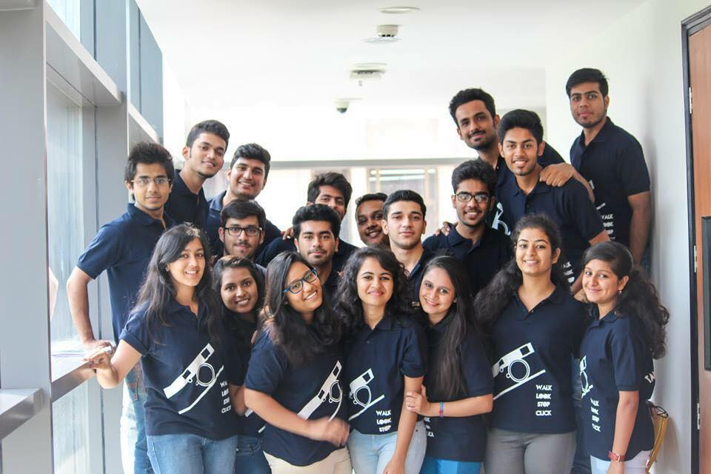

Jatin Gupta | Manager | April 3, 2016

Lumiere Activities 2015-2016

Contents

Students 2

Photowalk to Mehrauli Archaeological Park 3

Photography for University- Youth Parliament 5

Photography for University- Freshers 2015 6

Momentum: 2016 Chitrakala 7

Momentum: 2016 Kliek 6 9

Momentum: 2016- Inaugural Video 11

Momentum: 2016- Rebranding Video 11

Momentum: 2016- Covering Momentum Completely 11

Bechara Mara Gya : Abhimanch Play 24

Photowalk : NGO Aman Umeed Ghar 25

Several Photography tutorials and classes 29

Fiesta 2016 29

Covered Fiesta 2016 31

Humans of NCU 34

Lumiere 2016-2017 37

# Students

Interviews were conducted in the Month of September 2015 for new members.

|  |  |
| --- | --- |
| Name | Roll Number |
| Abhishek Shanker | 12ITU001 |
| akanksha gandhi | 12CSU012 |
| Anisha Sidana | 15CSU028 |
| Anmol Taneja | 15BCOM06 |
| Anubha Yadav | 12LLB010 |
| Arsh Munjal | 15CSU045 |
| Ashutosh goyal | 14cvu014 |
| bharti chauhan | bballb18 |
| Bhaviya batra | 15CSU053 |
| Brijesh Goel | 12ITU012 |
| Diksha vikas | 13itu007 |
| Divyanshu | 12itu016 |
| Dushyant kapoor | 13Ecu044 |
| Ekta Gupta | 15CSU067 |
| Himanshu Yadav | 13csu052 |
| Ishita Aggarwal | 13CSU054 |
| Jatin chawla | 15ECU026 |
| Jatin Gupta | 13CSU055 |
| Kamalpreet Kaur | 11llb031 |
| Kushagra Gupta | 12CSU142 |
| Kushagra Nirula | 15LLB033 |
| Madhukar Sharma | 13ecu078 |
| Malvika Sharma | 13ecu080 |
| Manik Kumar | 15CSU114 |
| Manu Gupta | 15CSU116 |
| mehak jain | 12EEU028 |
| Neelakshi Sharma | 13itu020 |
| Nishtha Grover | 12ECU070 |
| Pranay Bhardwaj | 12ECU079 |
| Rajat chawla | 12ECU094 |
| Ravleen Kaur | 12itu035 |
| Ruhan Goel | 15ECU043 |
| Simran Nandwani | 15LLB064 |
| Smriti Goel | 13ITU041 |
| Tanisha Manocha | 13CSU129 |
| Tanya Pahuja | 12itu045 |
| Tejas Arya | 14CSU220 |
| Upinder Singh | 12LLB081 |
| Vaishali aggarwal | 15BSECO017 |
| Vishal | 12csu135 |

# Photowalk to Mehrauli Archaeological Park

Date:20 Sept.

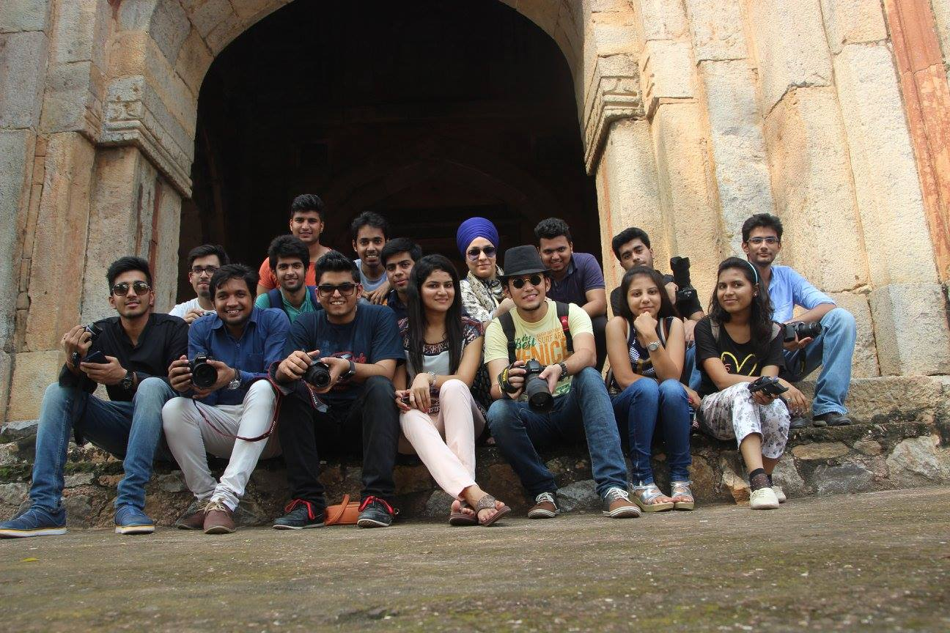

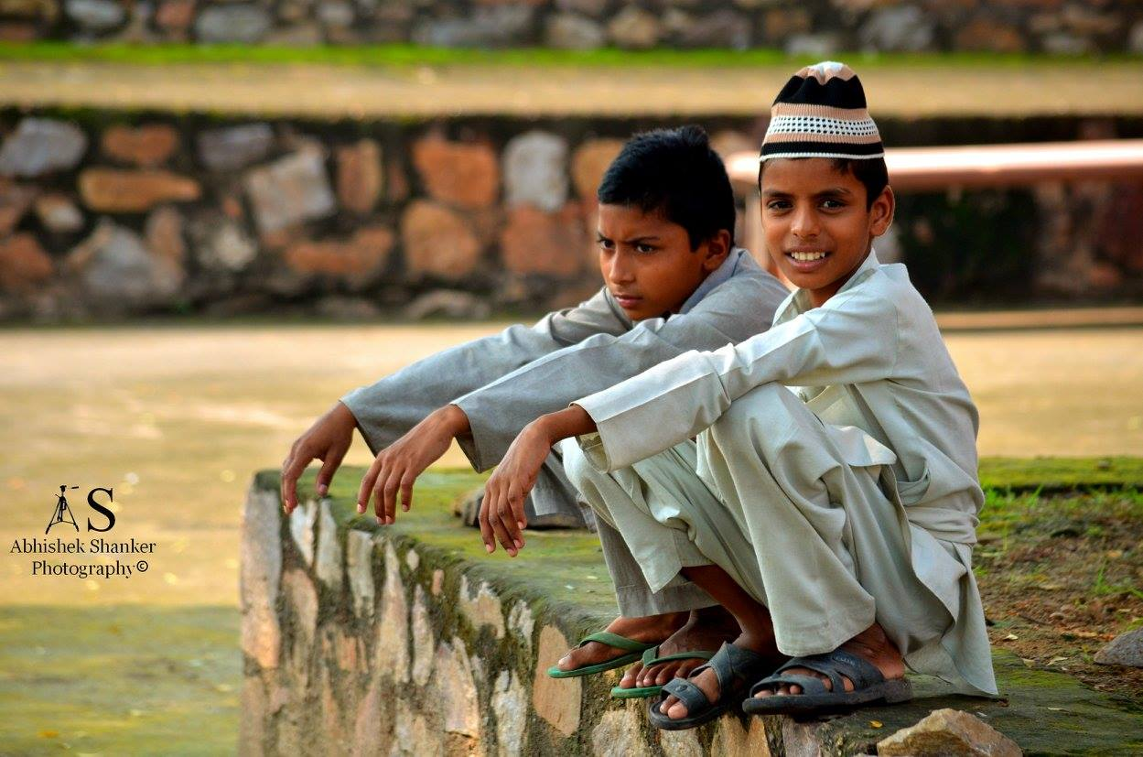

# Photography for University- Youth Parliament

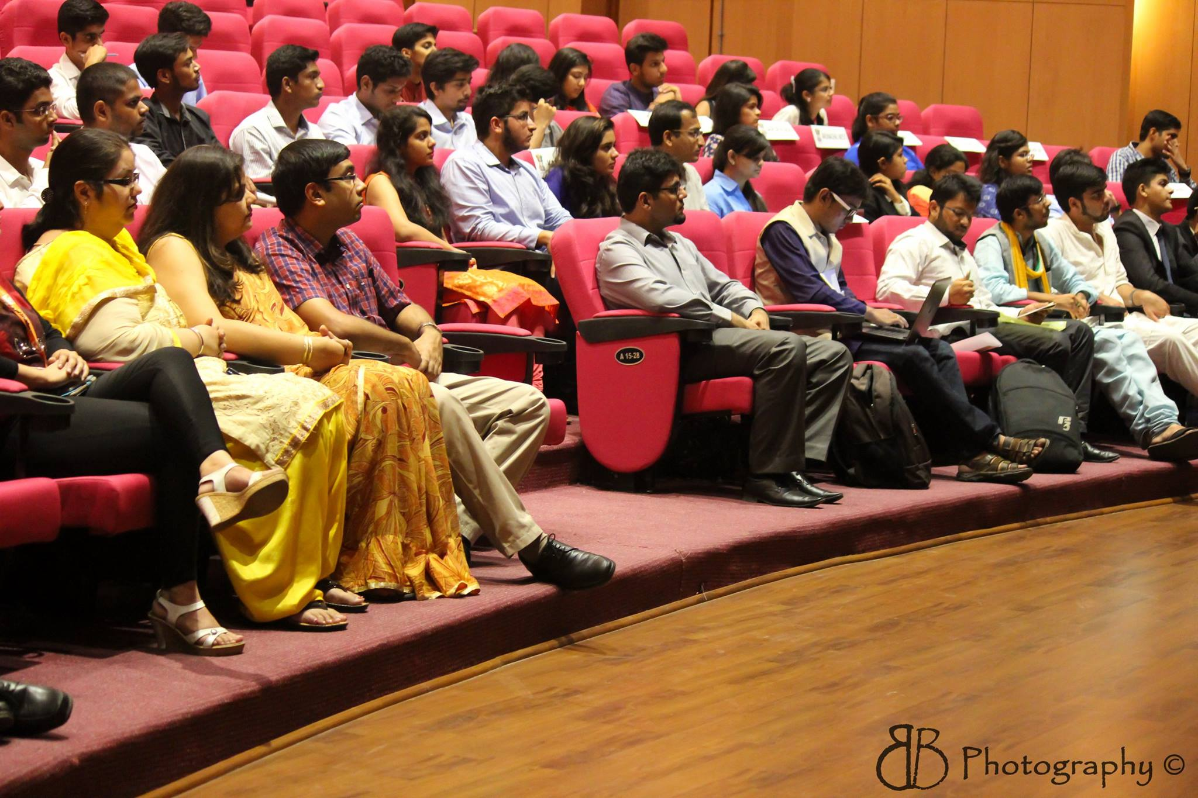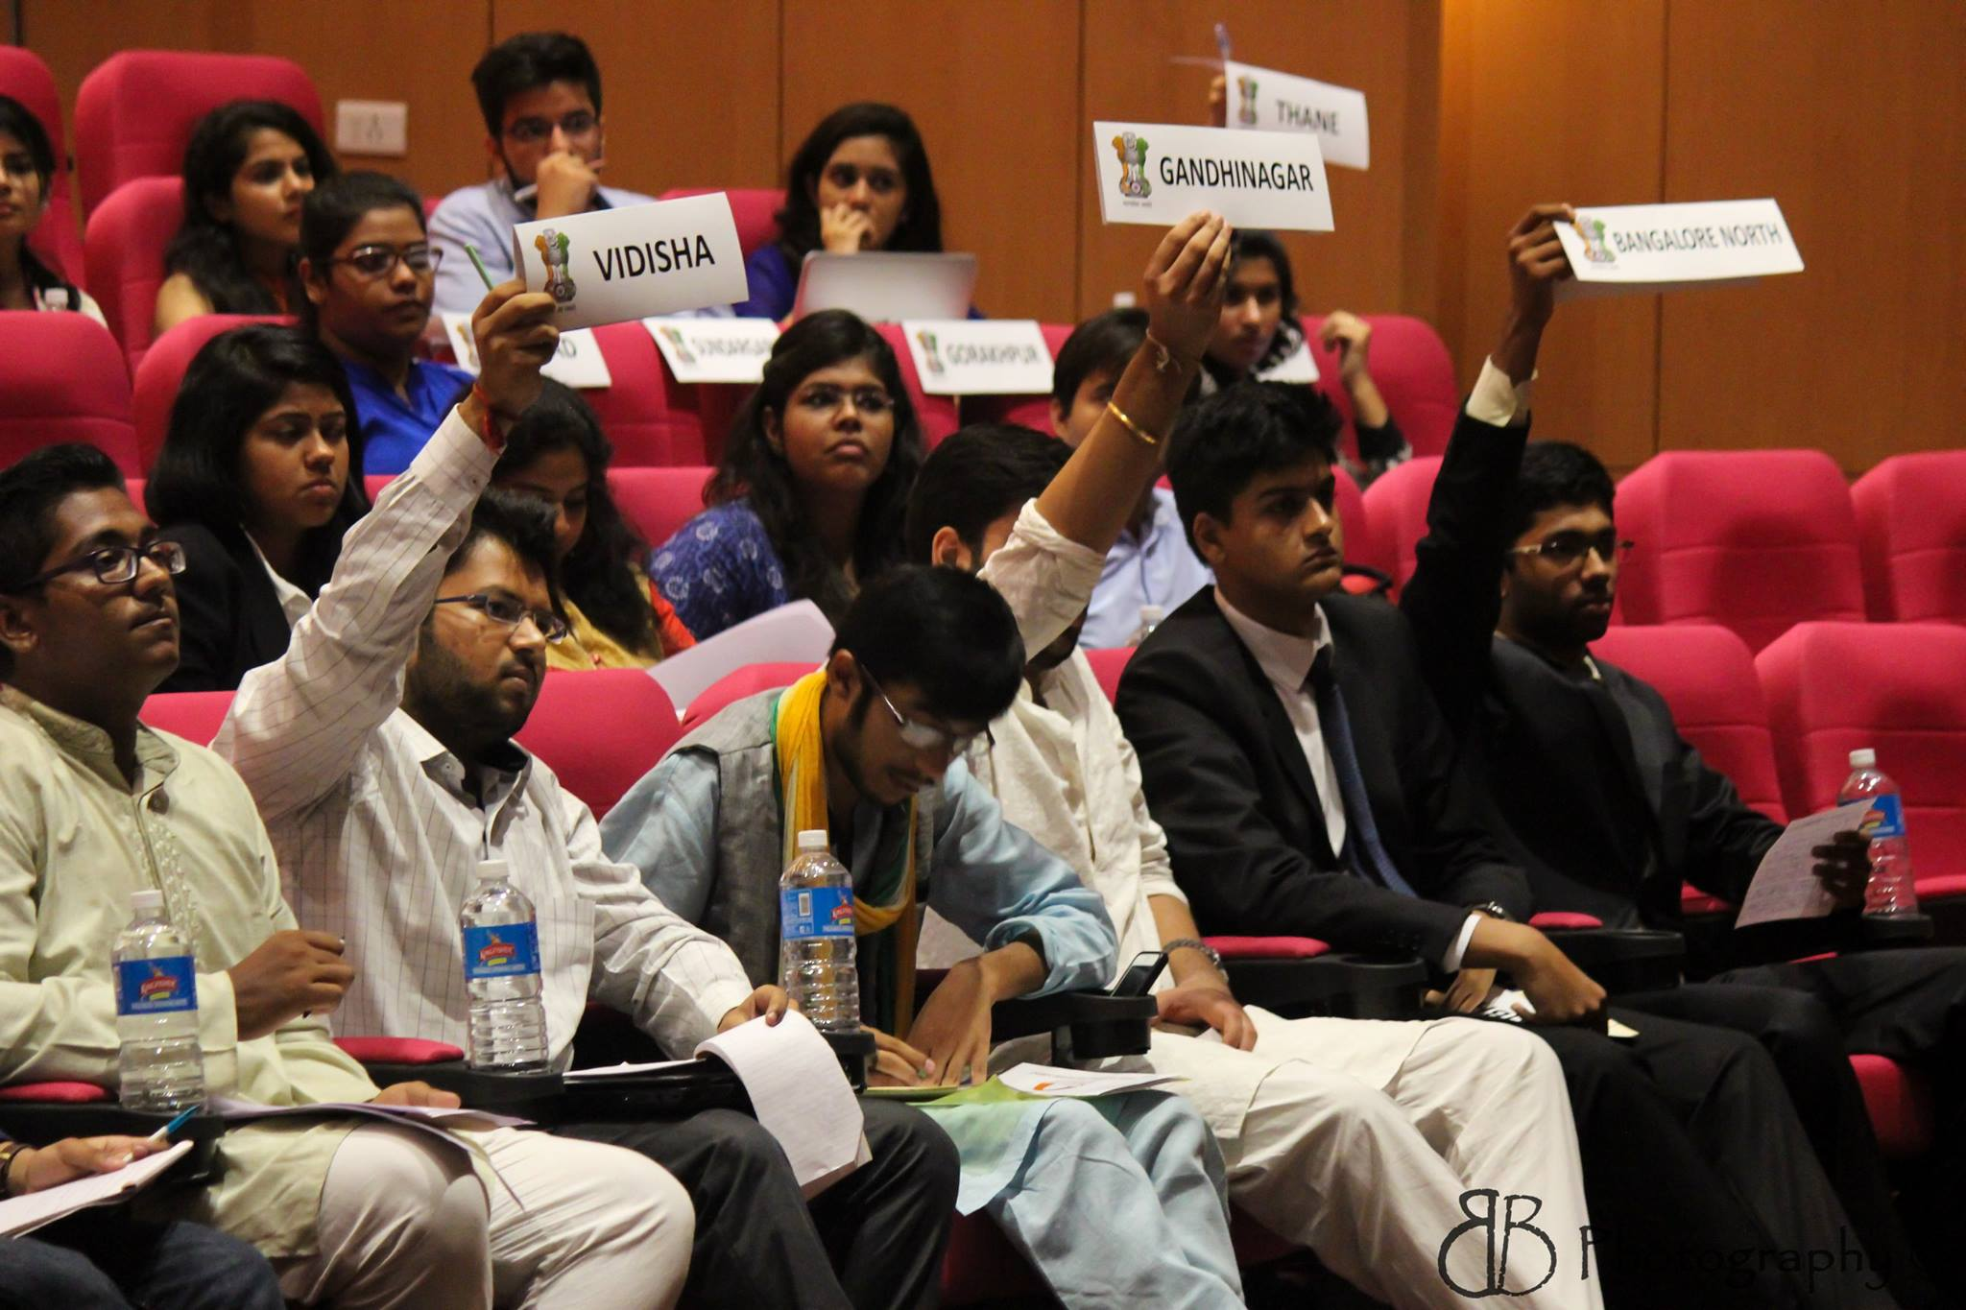

# Photography for University- Freshers 2015

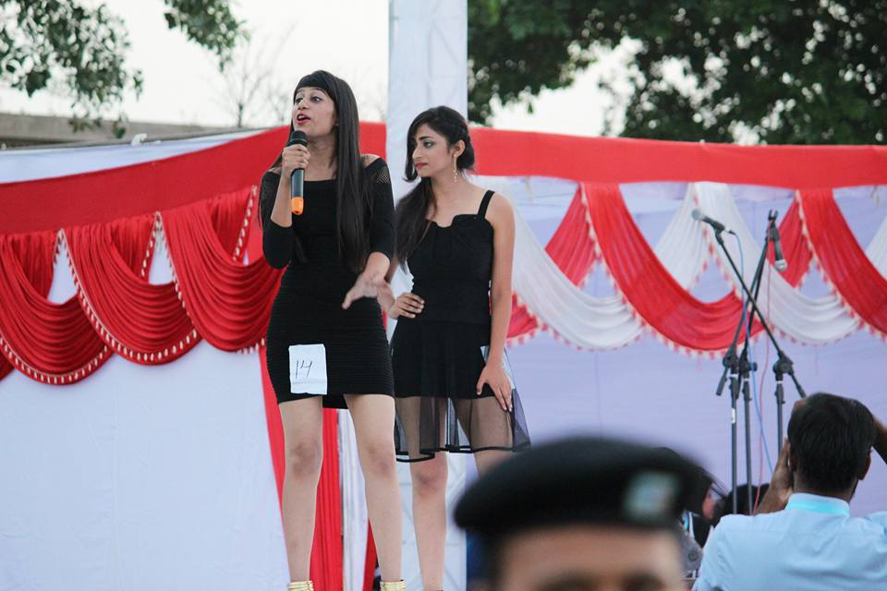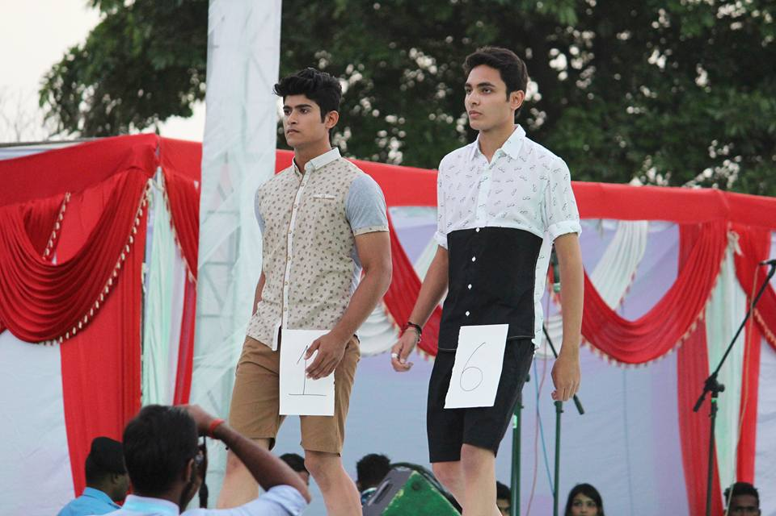

# Momentum: 2016 Chitrakala

Its an online photography competition which involved over 50 participants with over 150 photos. 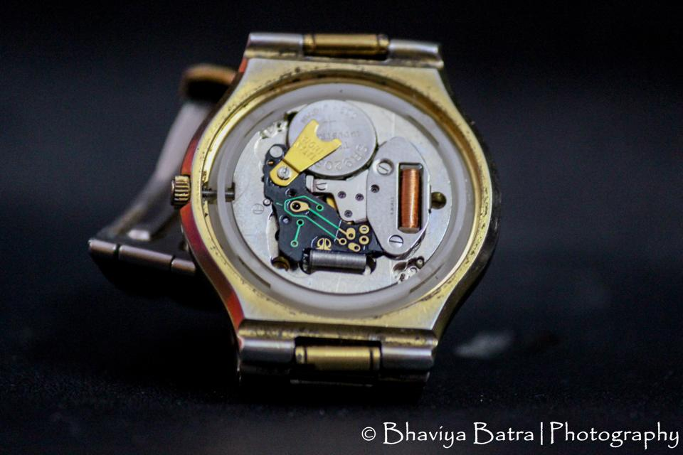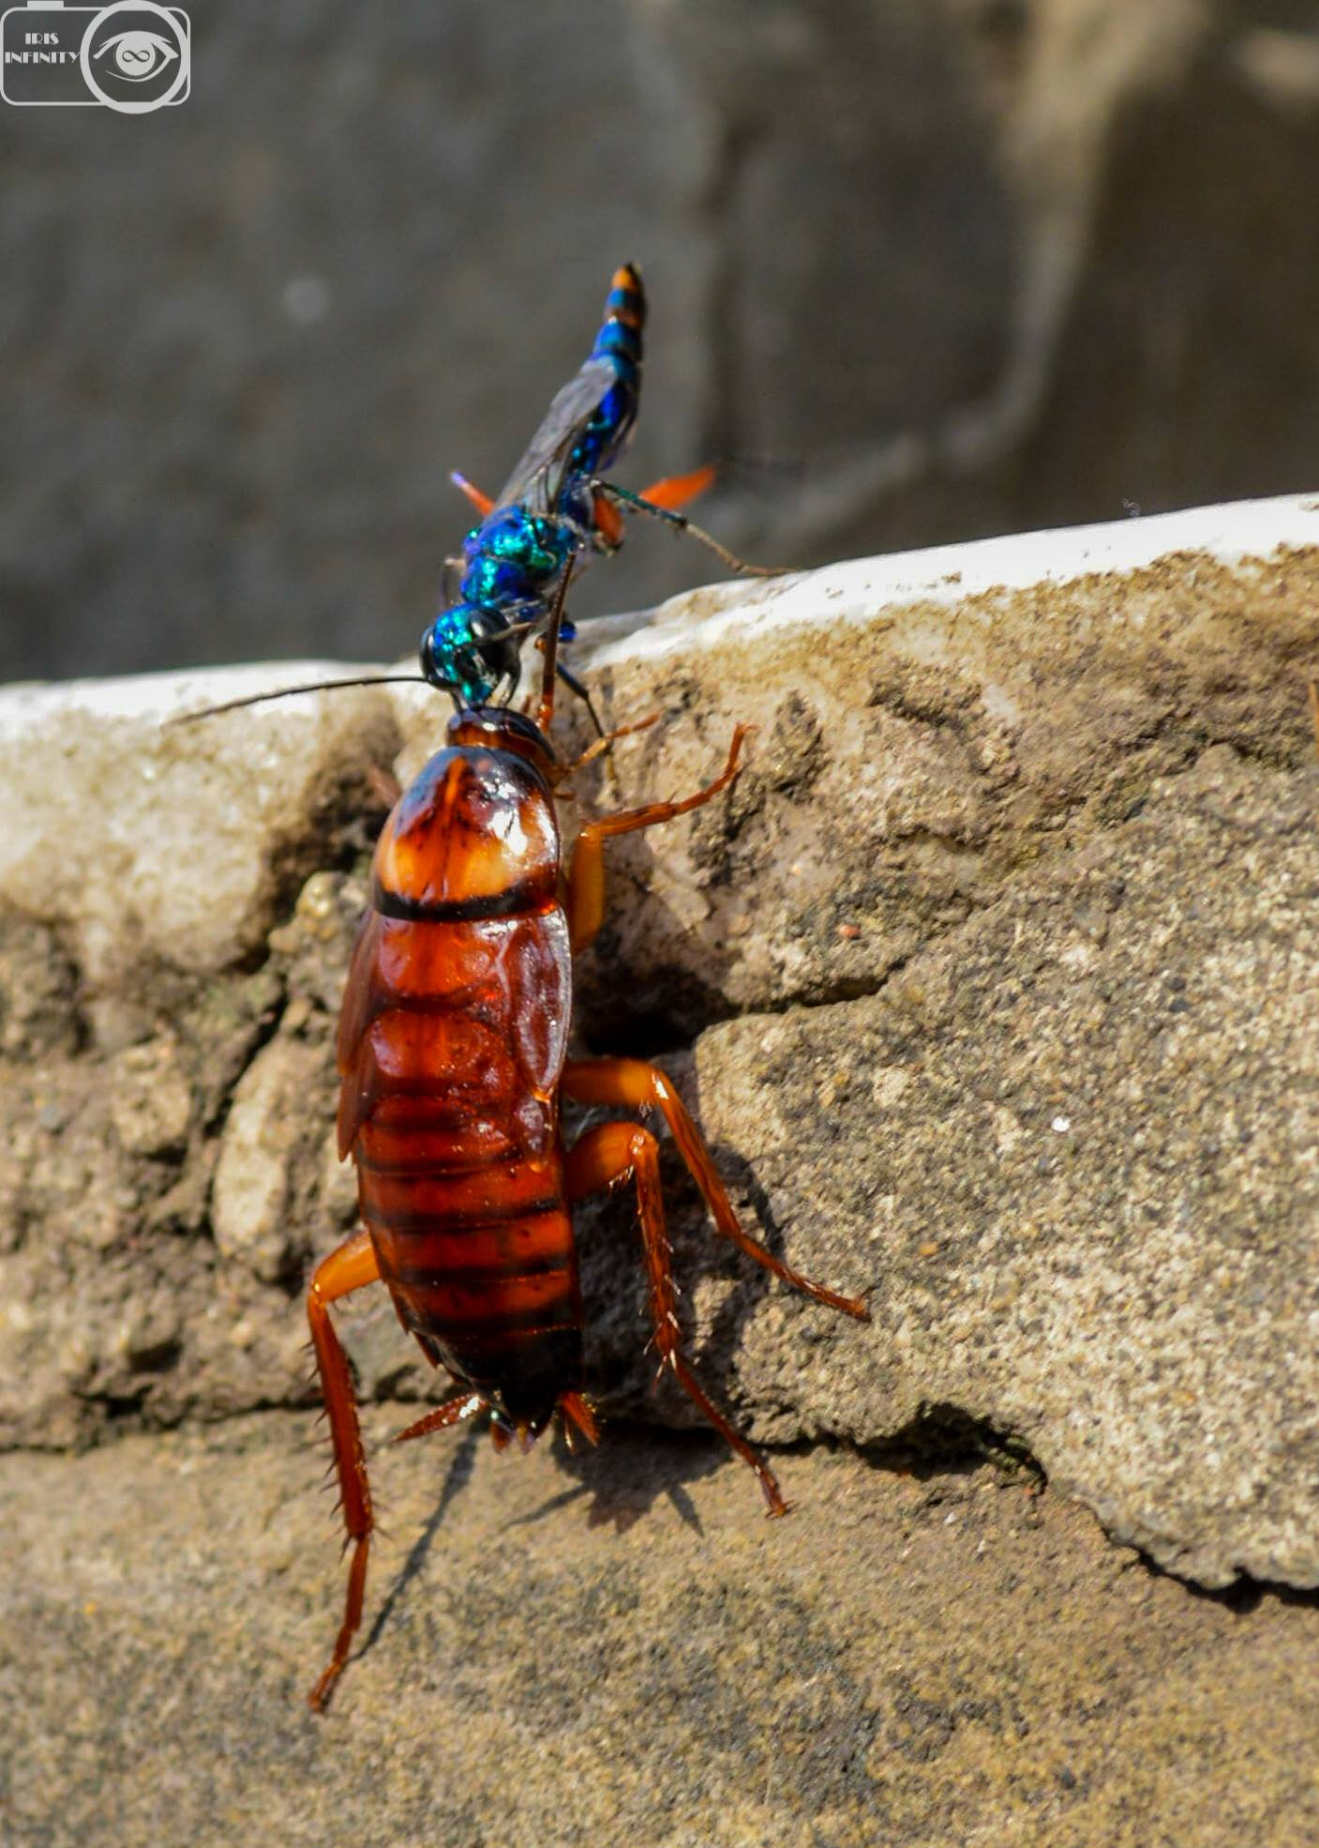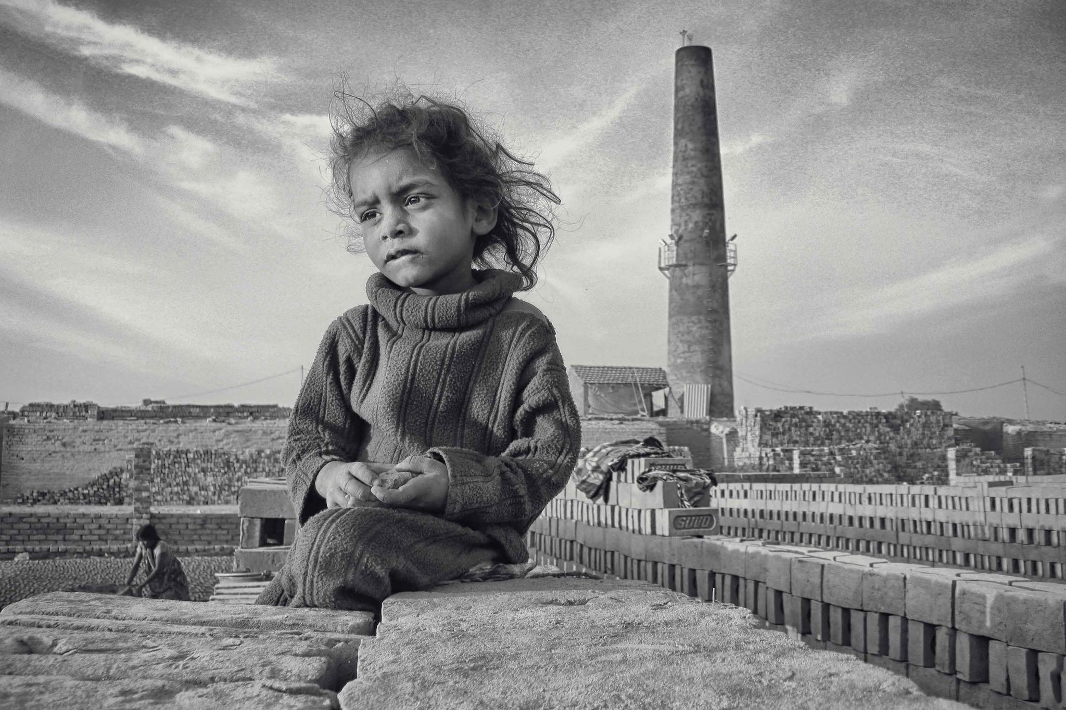

# Momentum: 2016 Kliek 6

Sixth iteration of our photography Exhibition. With over 60 participants and 100+ photos on display.

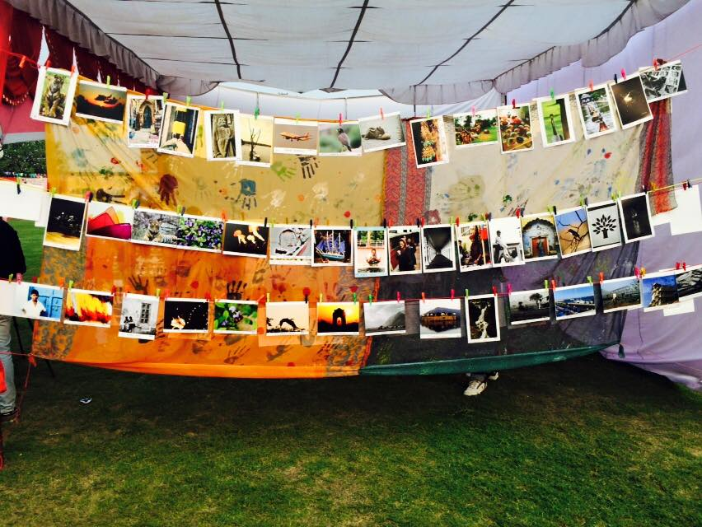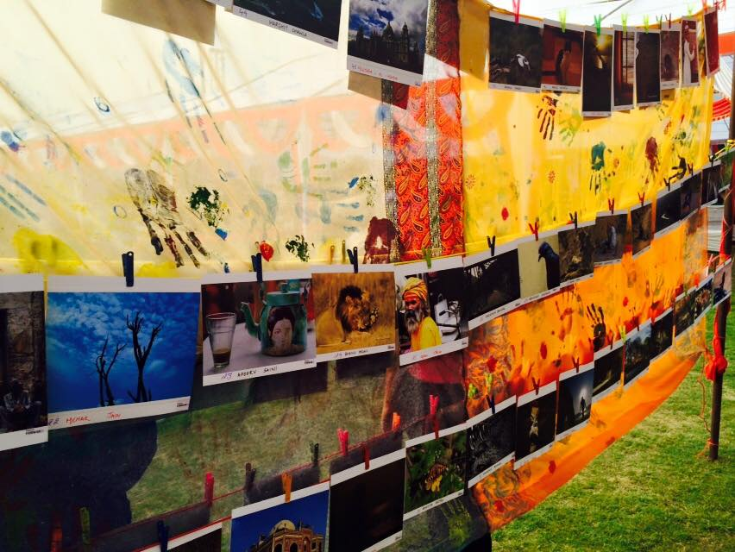

# Momentum: 2016- Inaugural Video

Complied by Lumiere members.

# Momentum: 2016- Rebranding Video

Compiled by Lumiere members.

# Momentum: 2016- Covering Momentum Completely

With over 10000 photos and selected 4000 uploaded on social media.

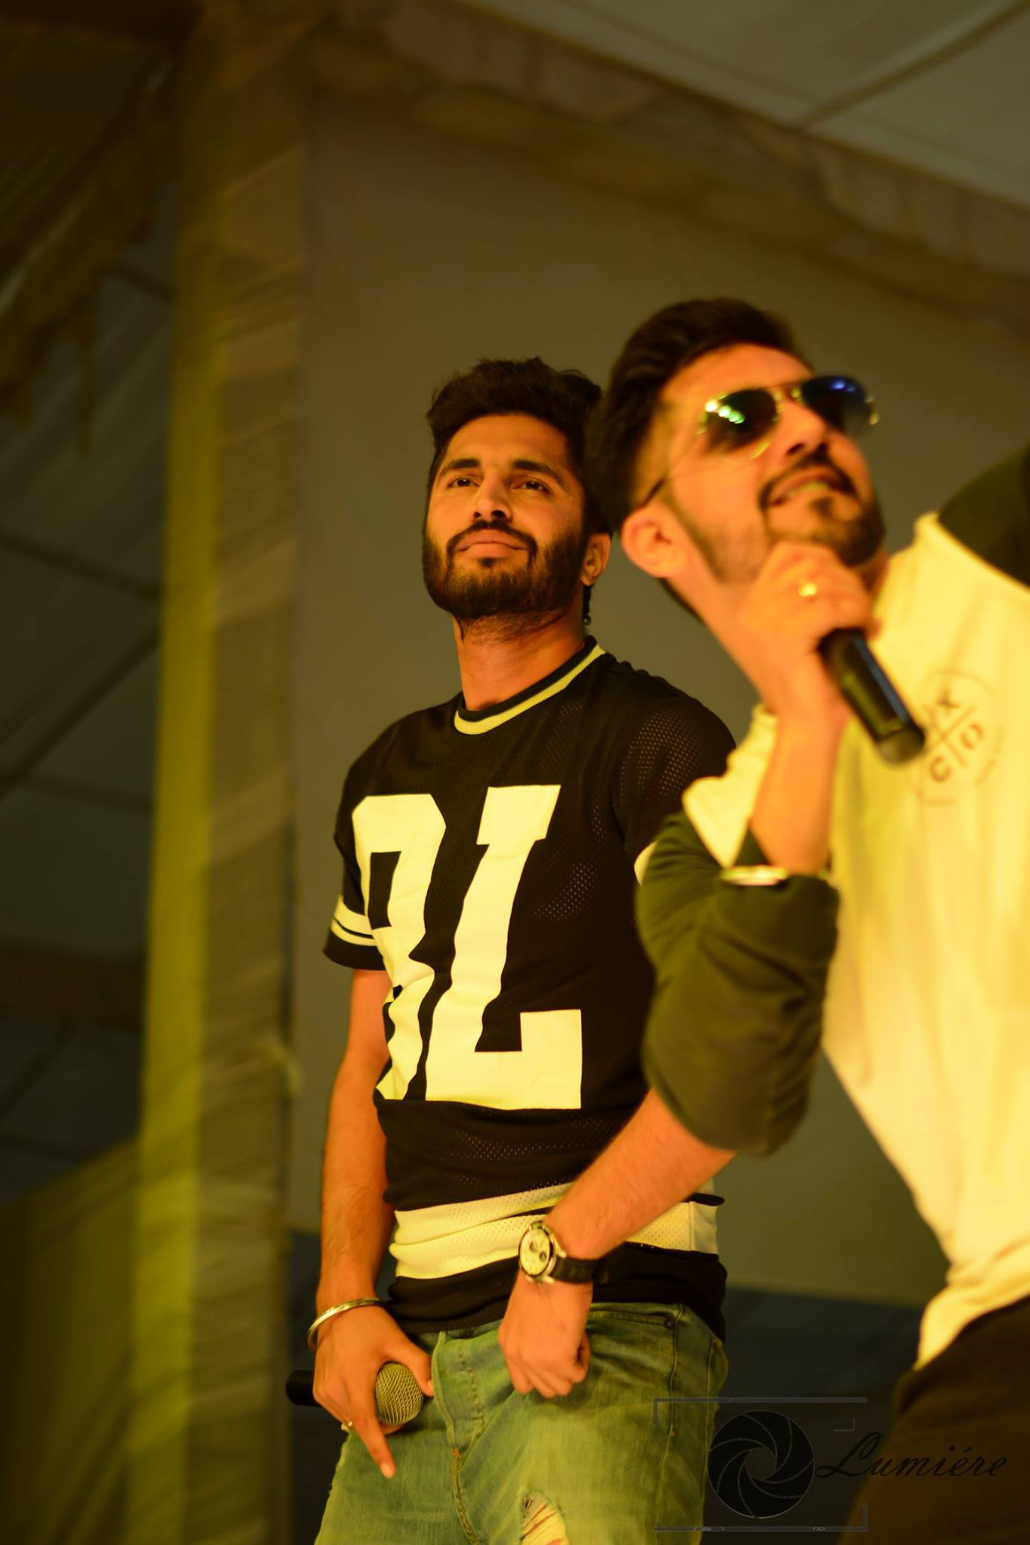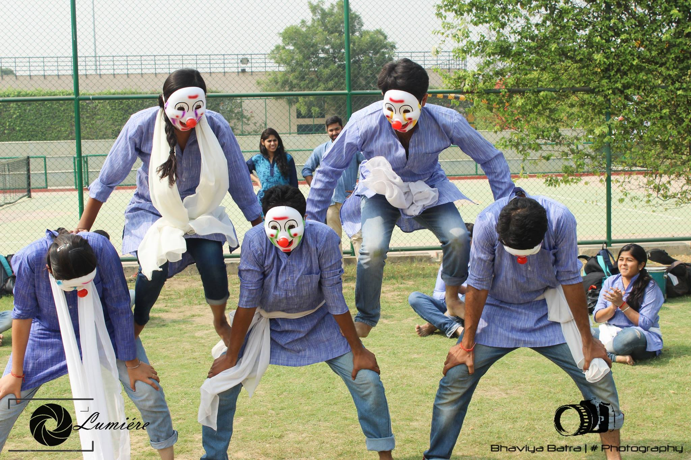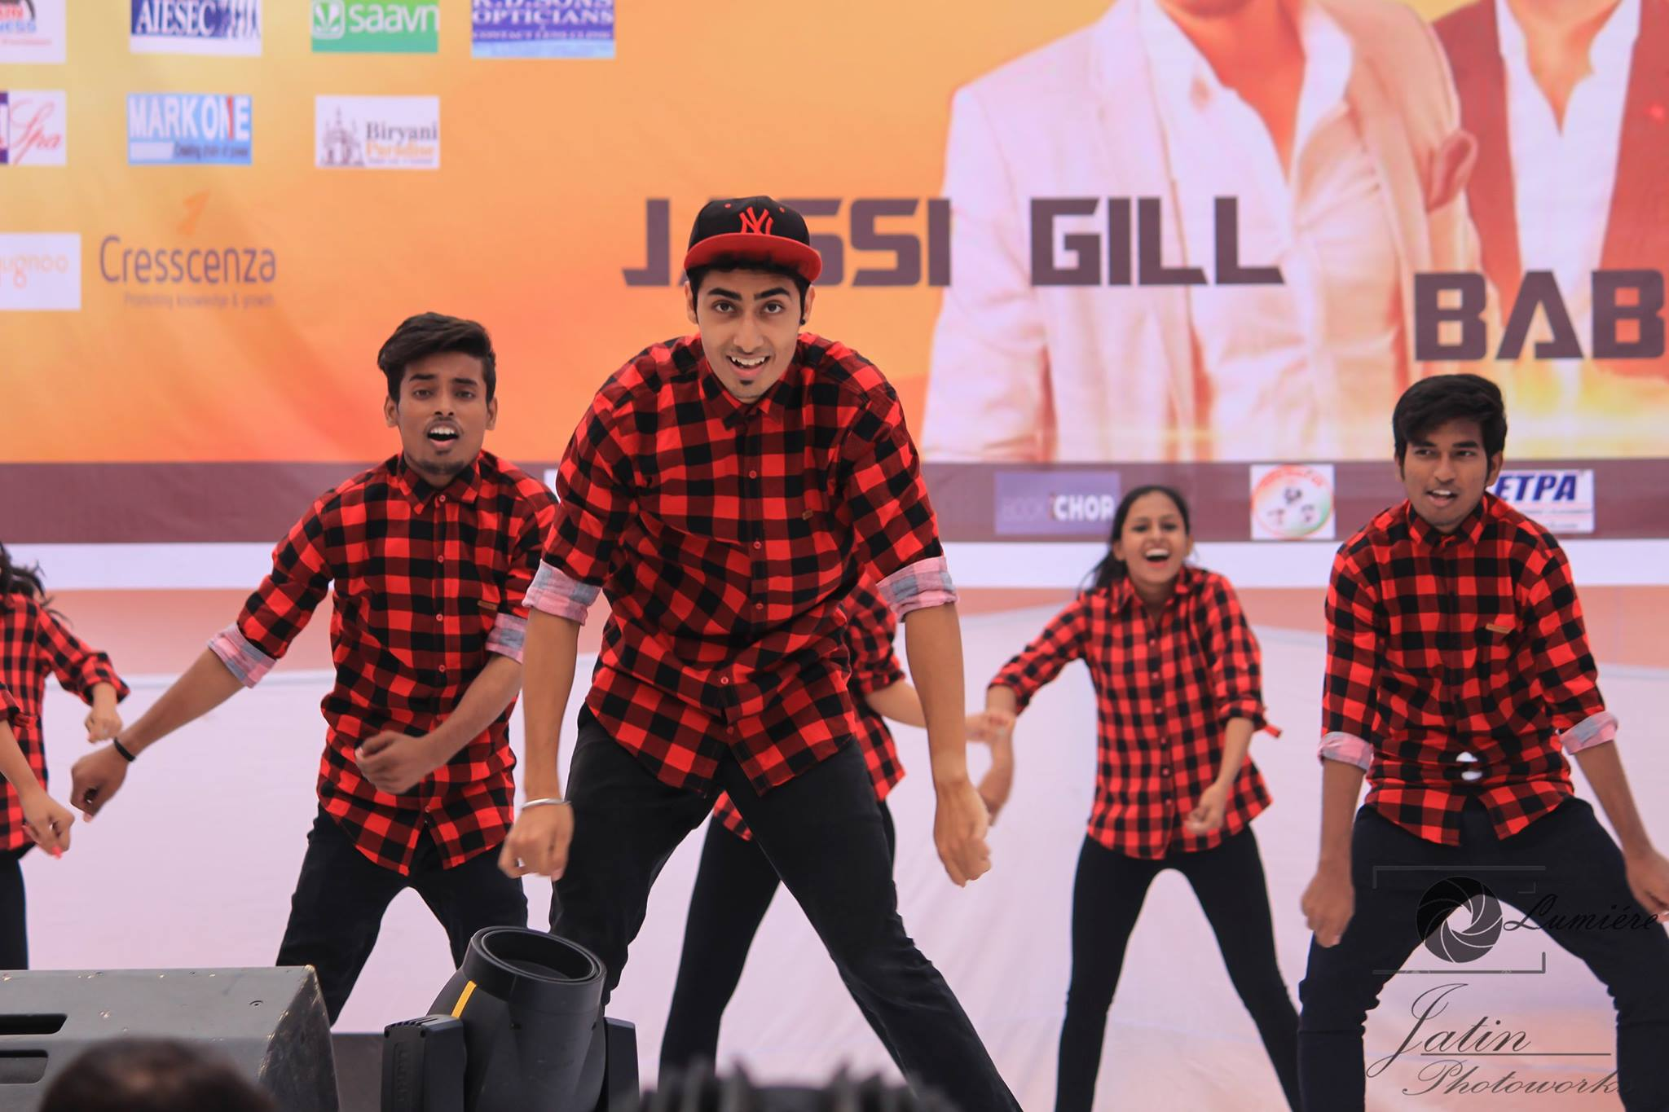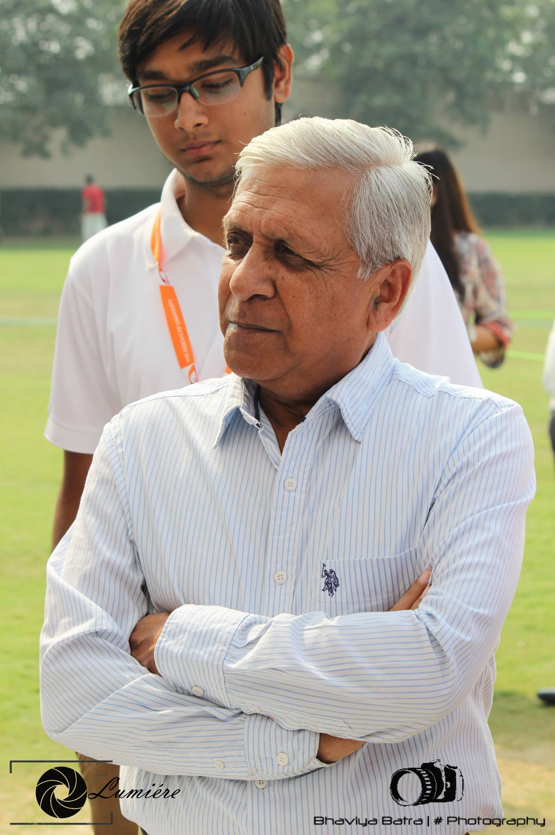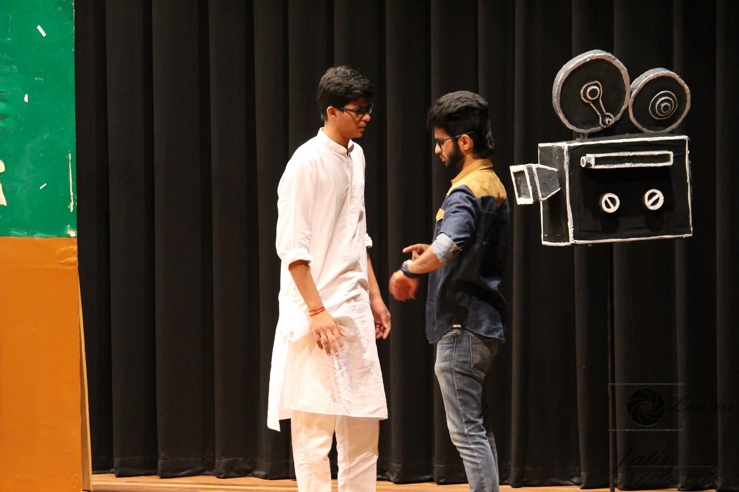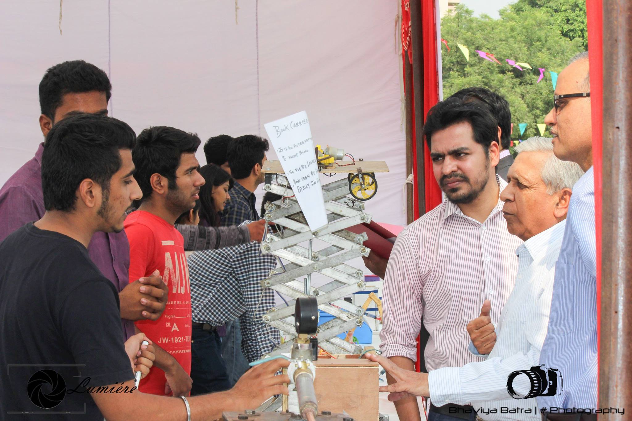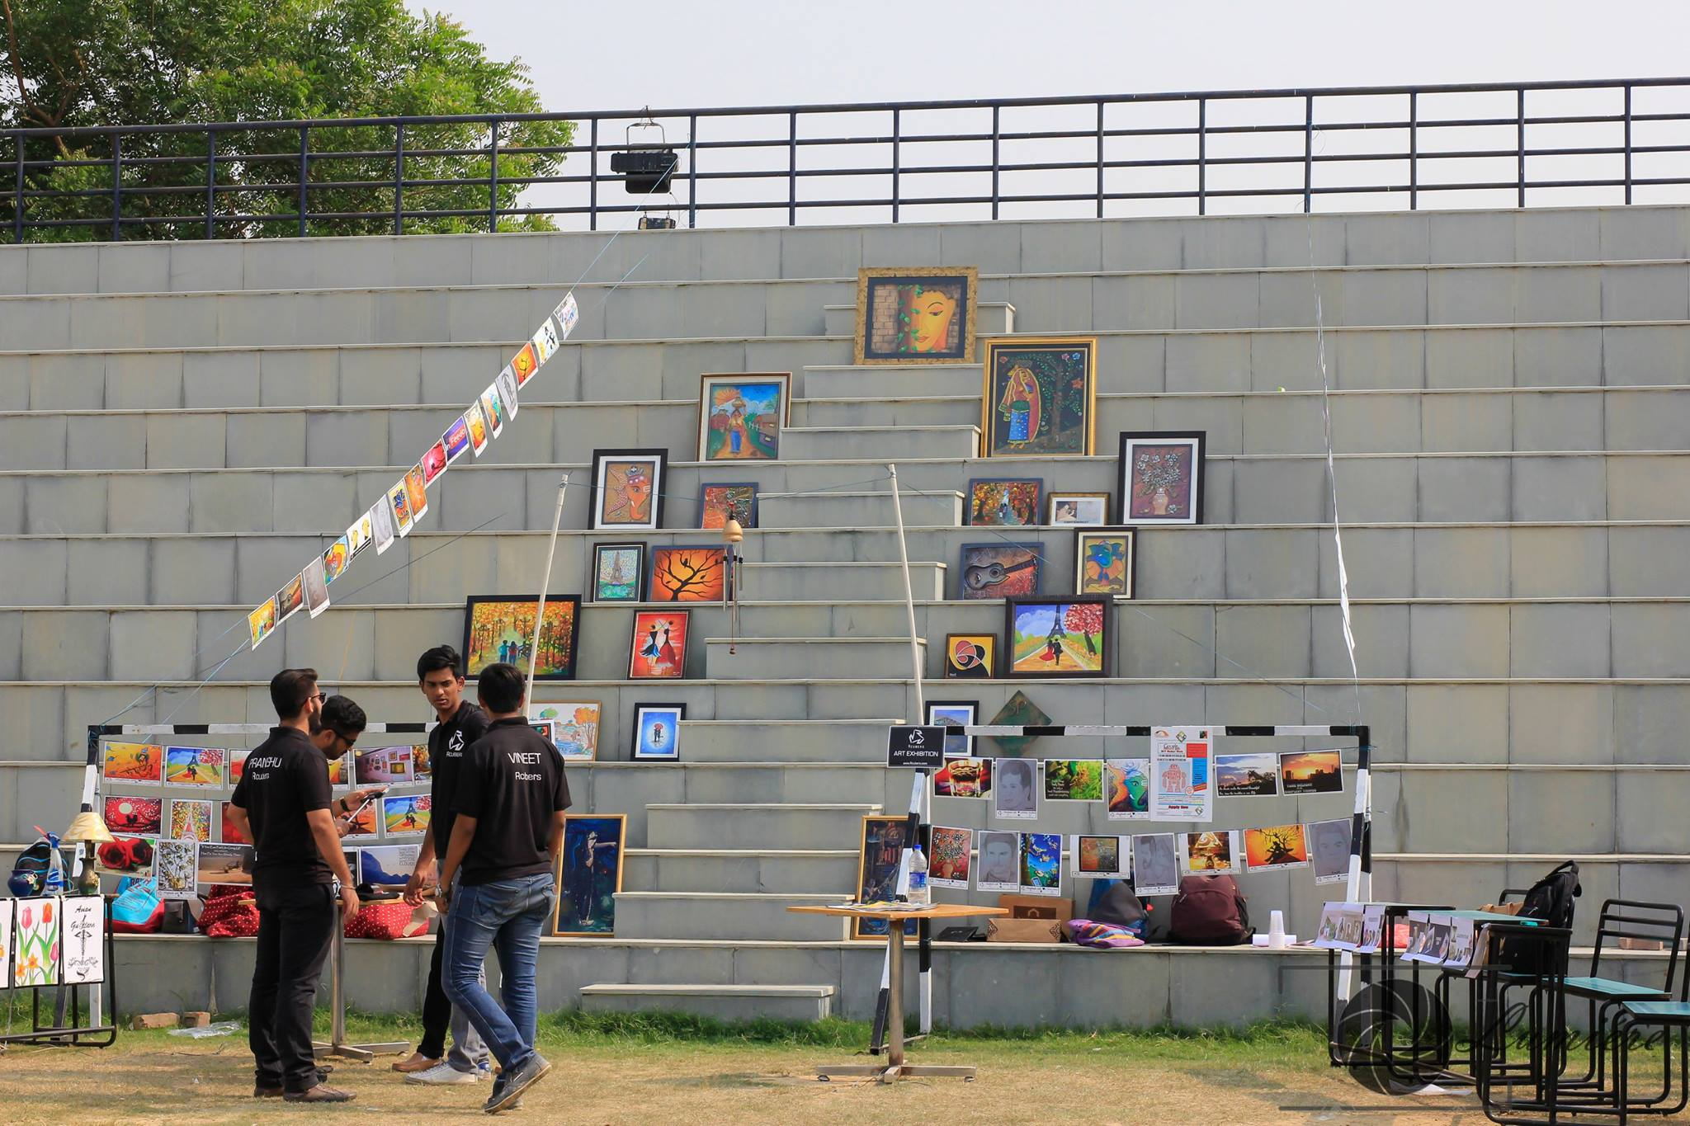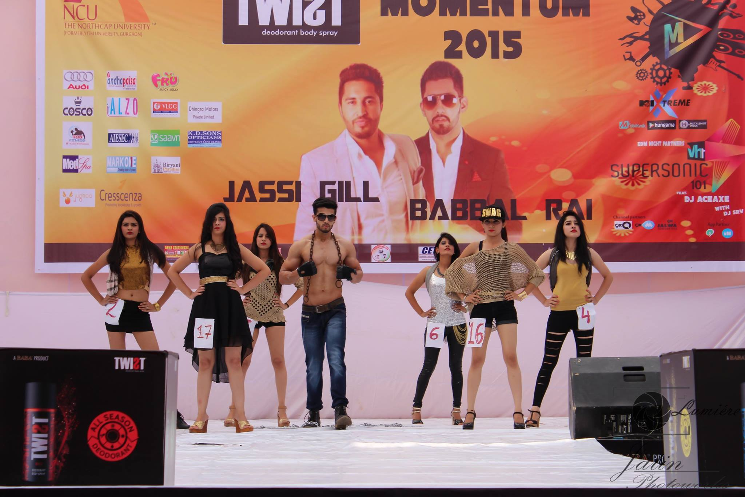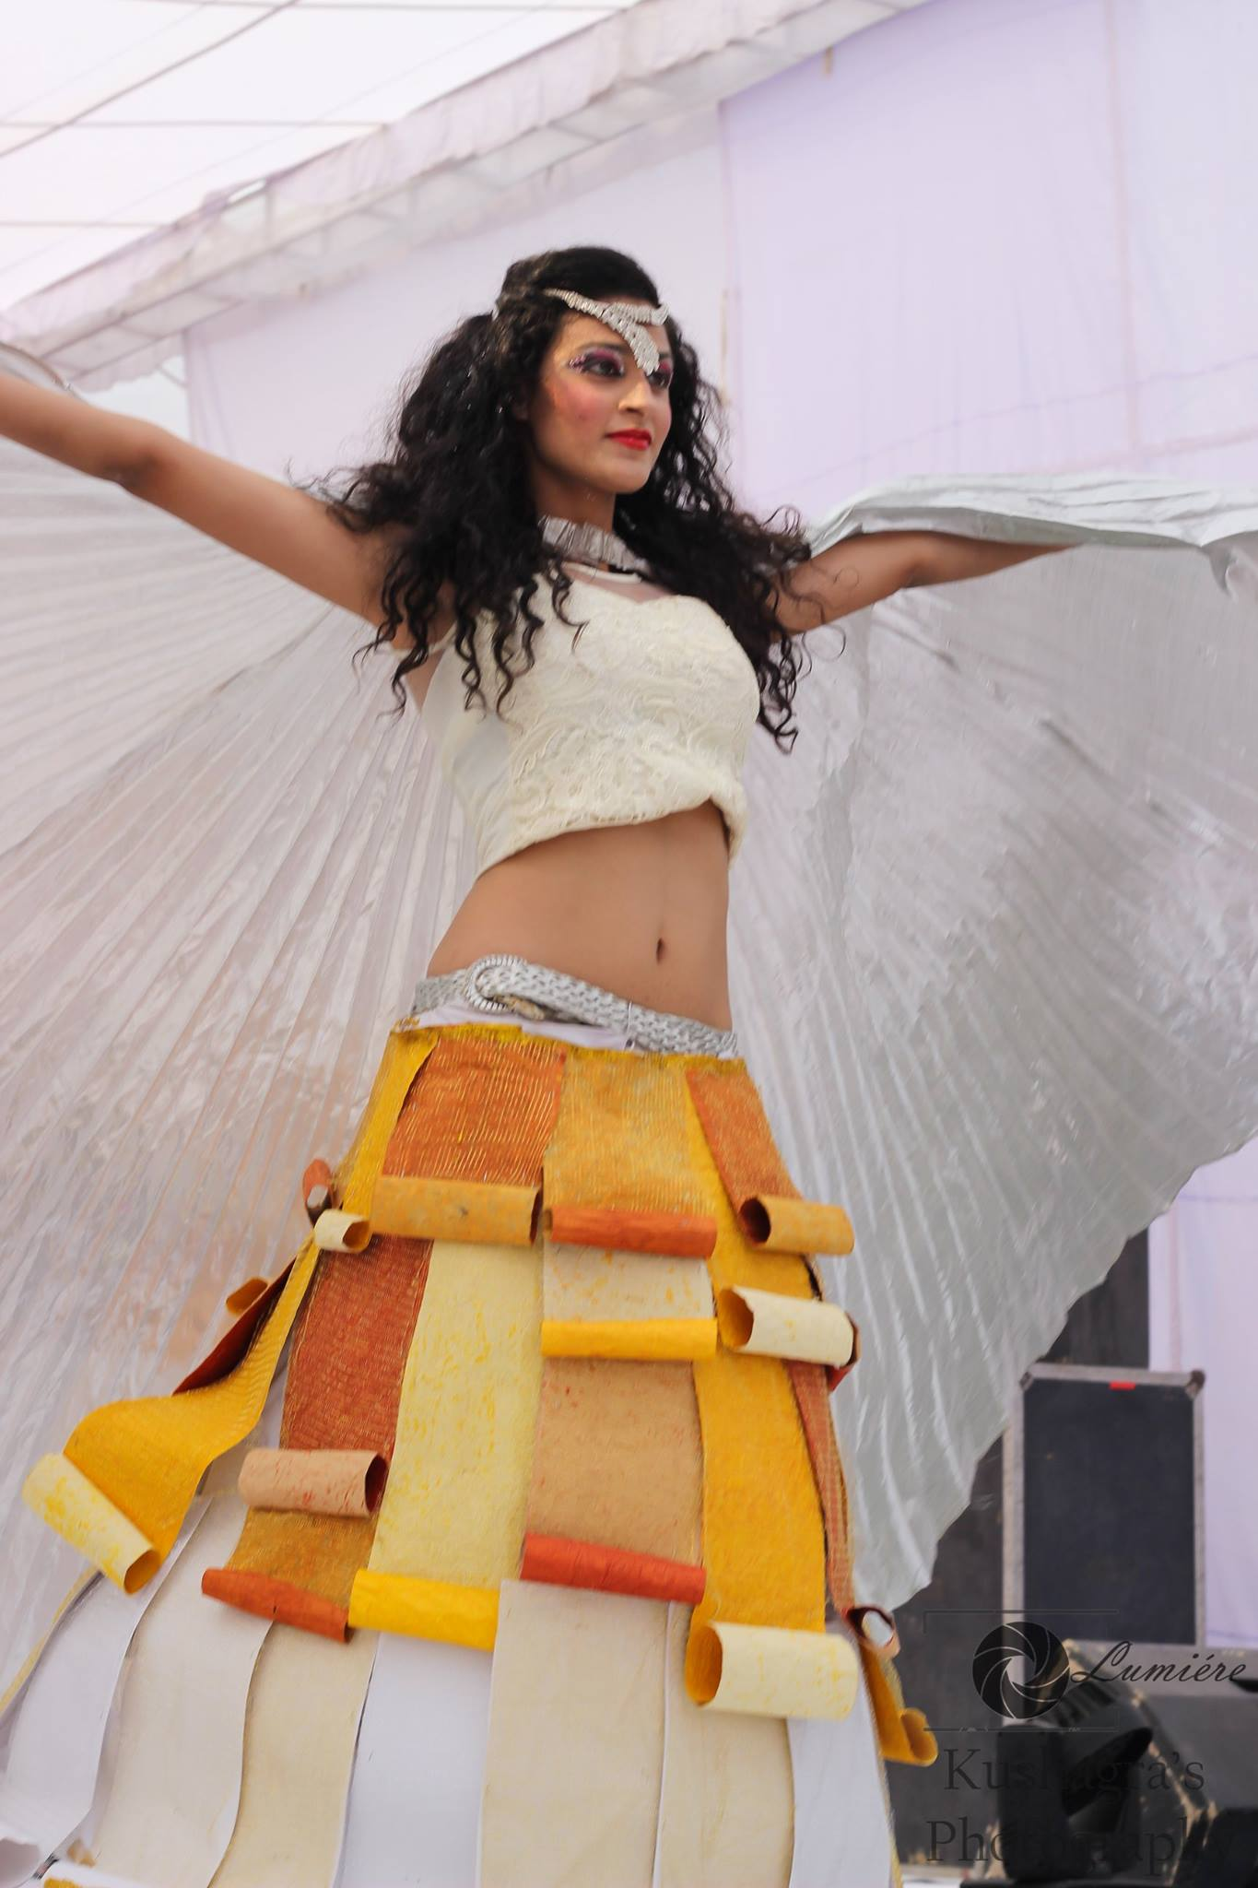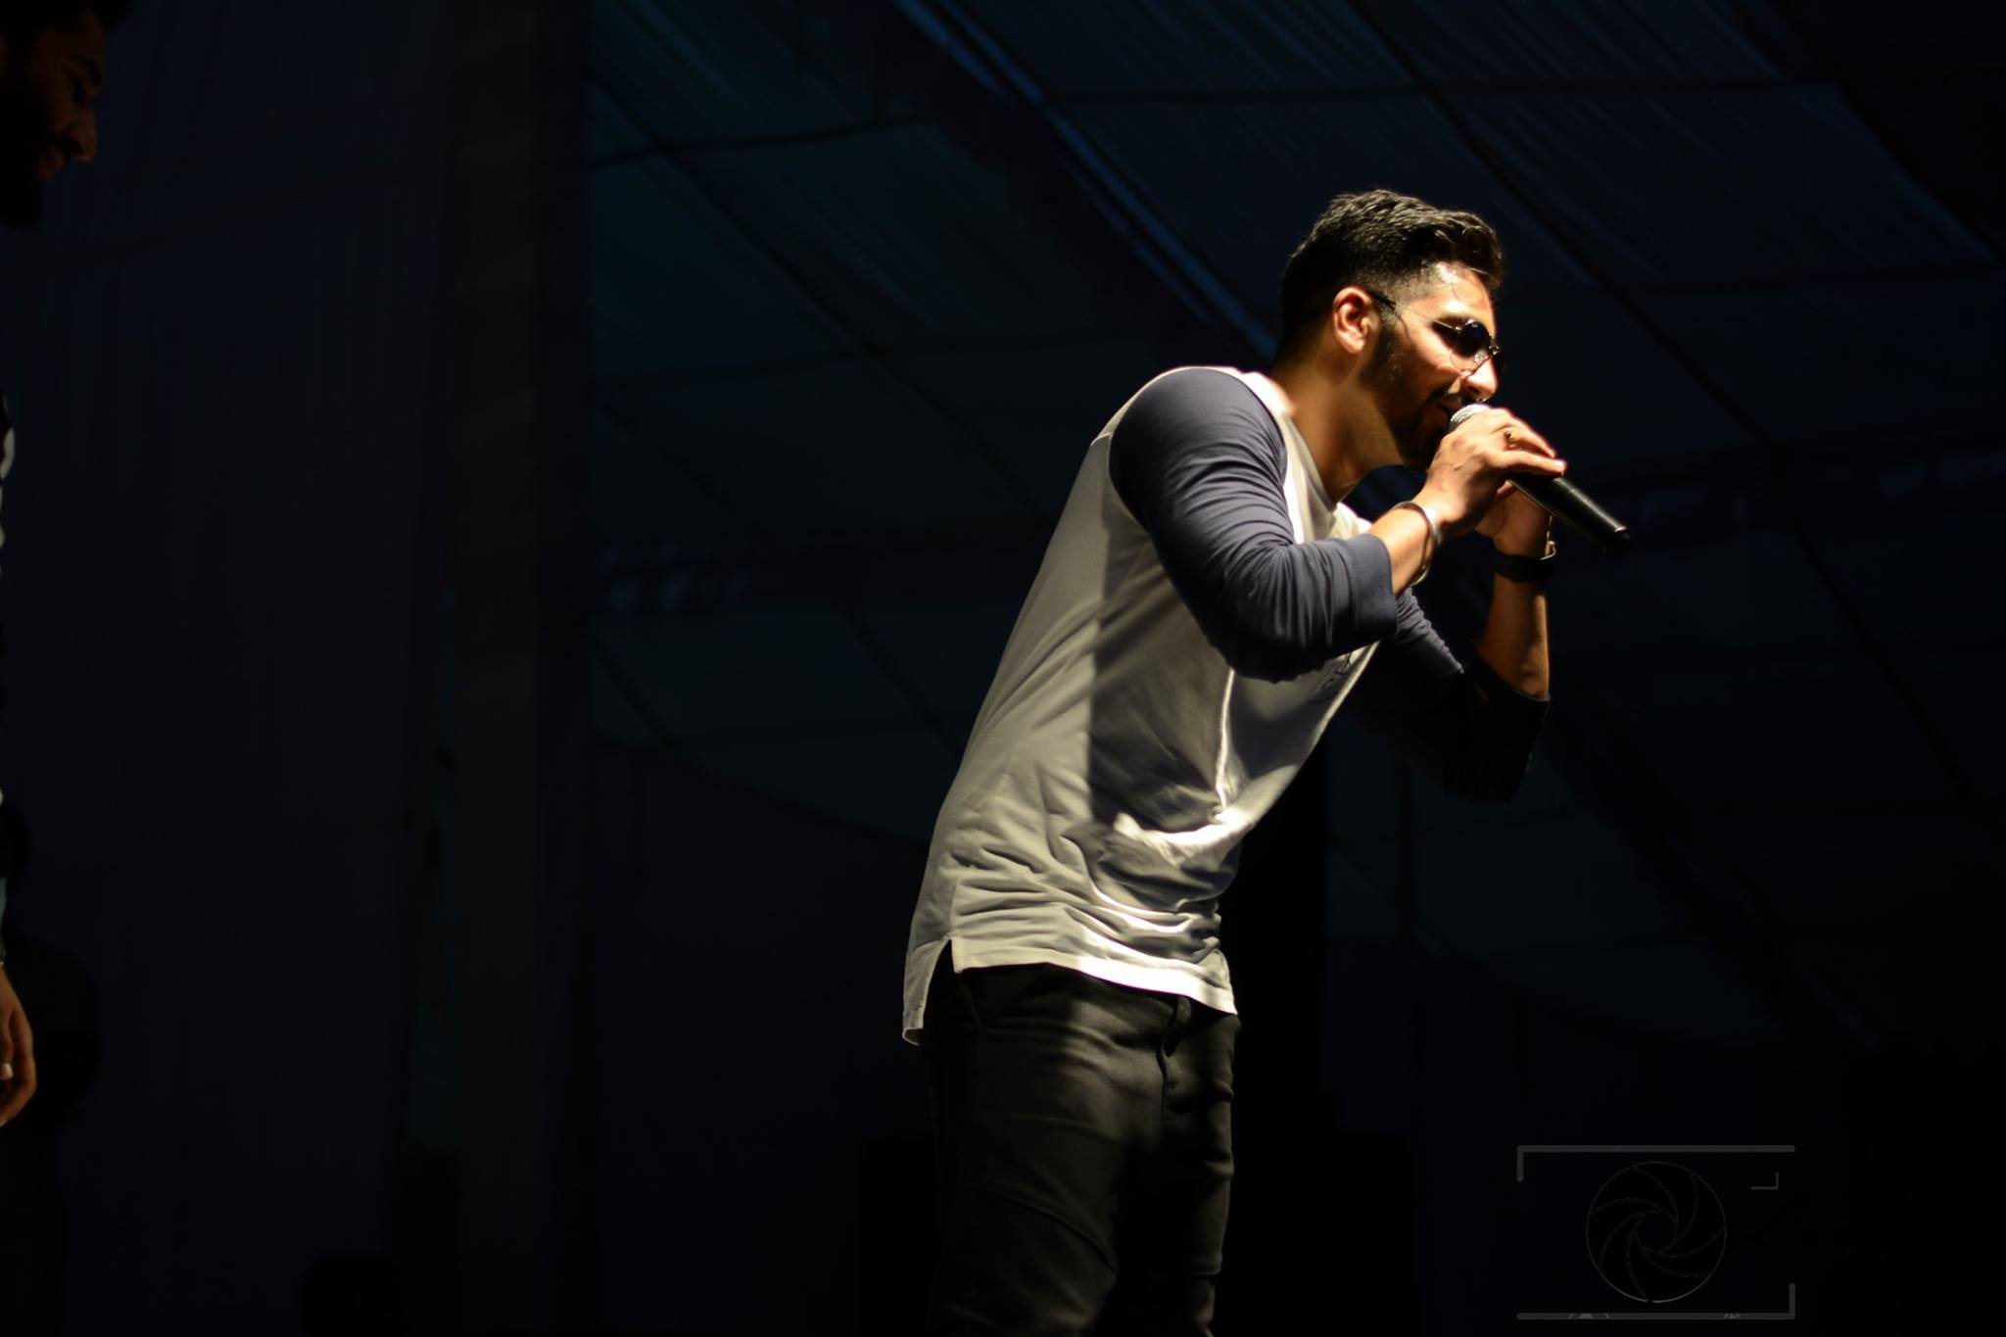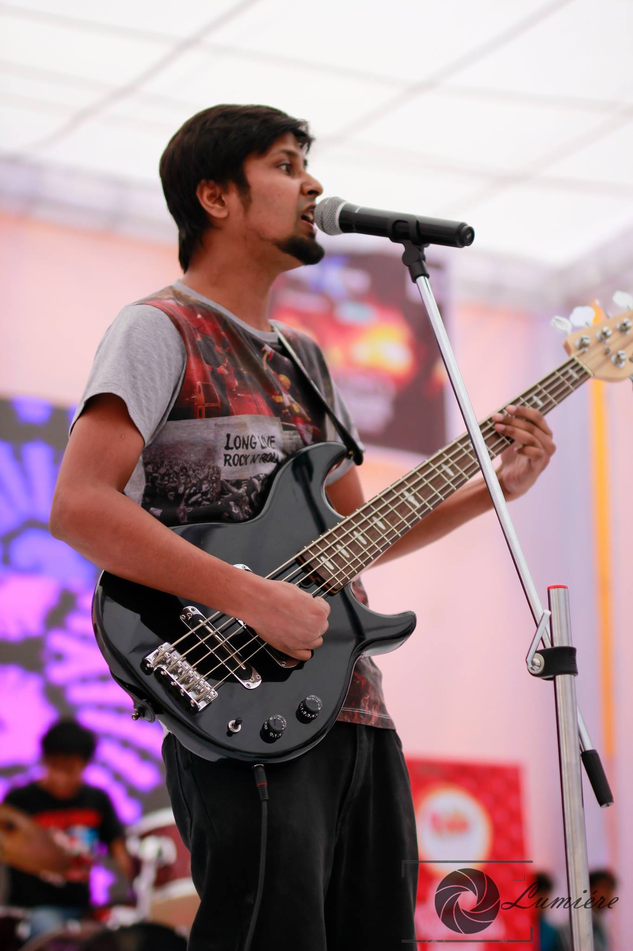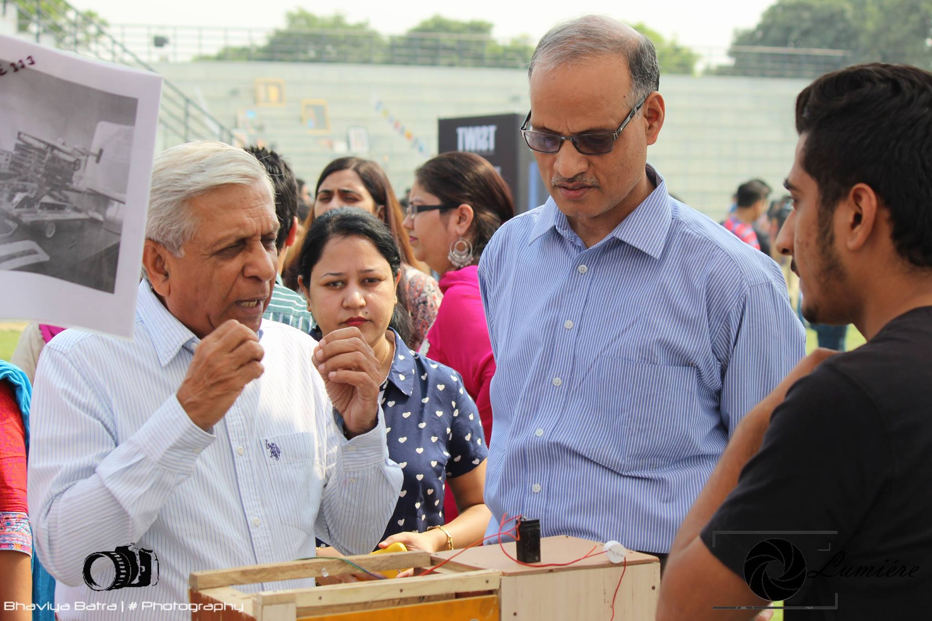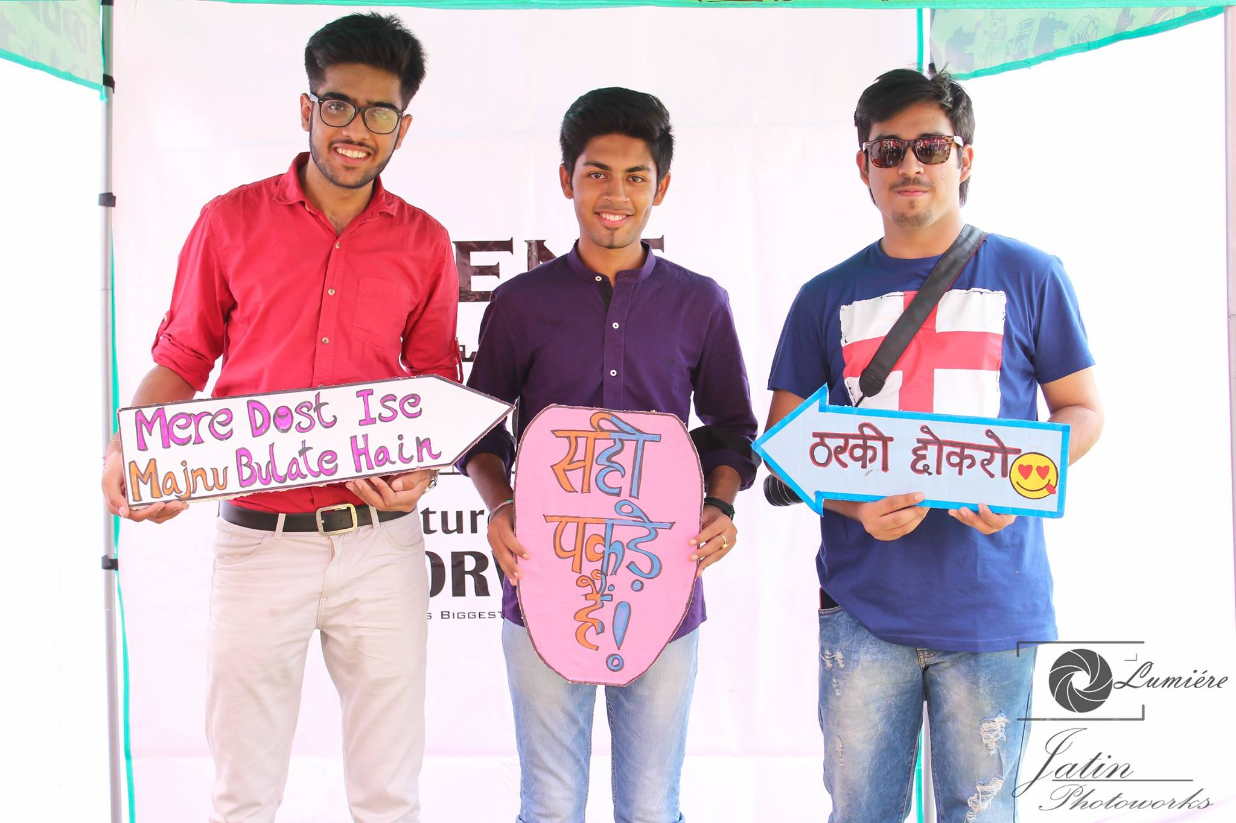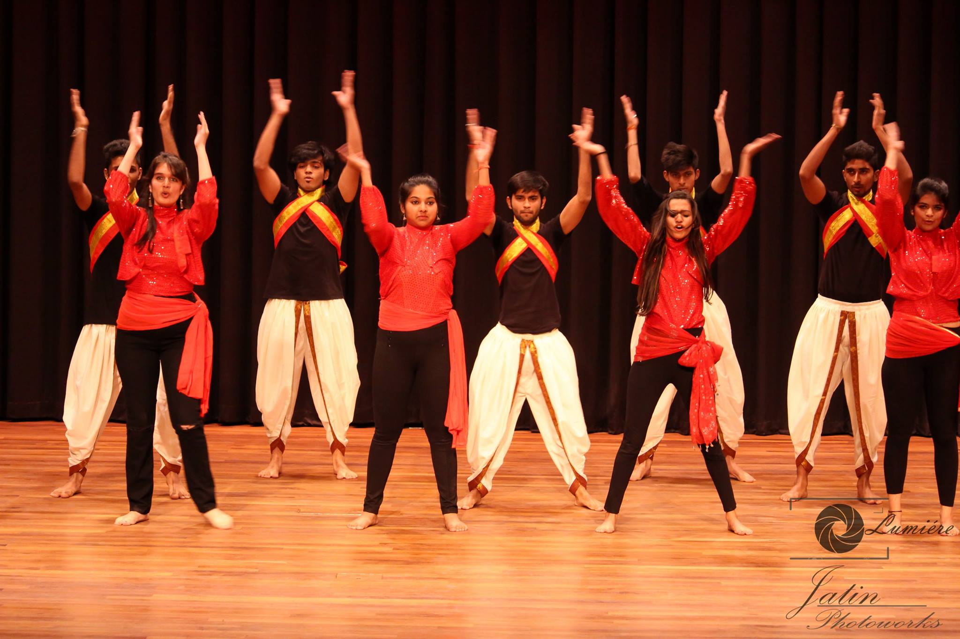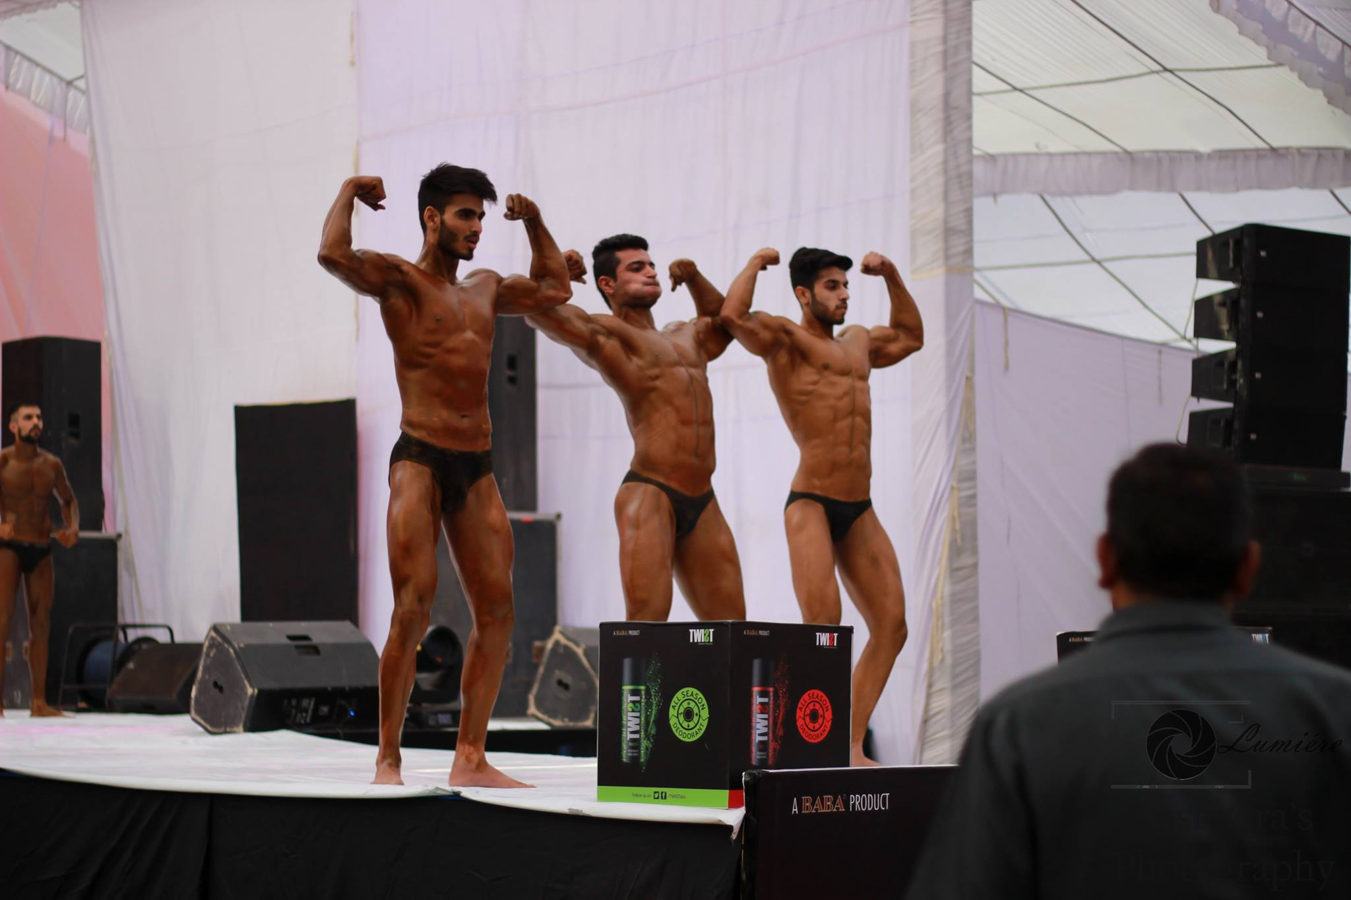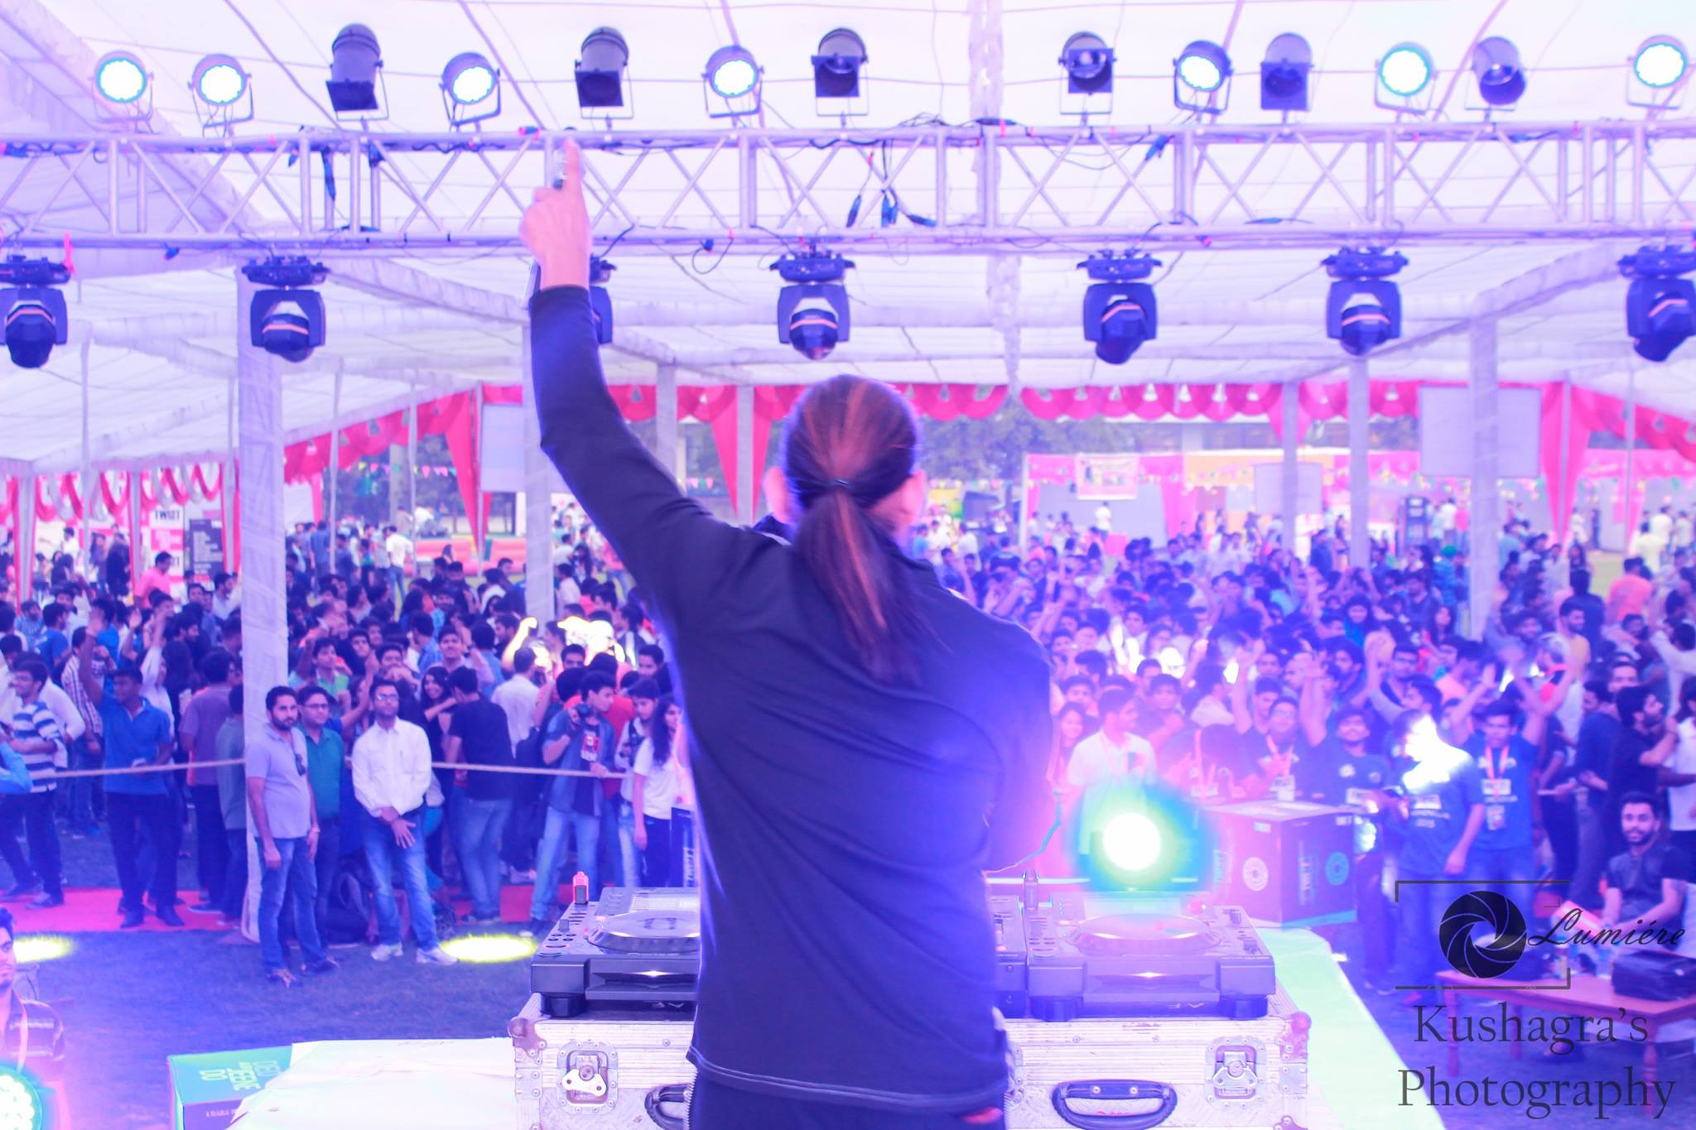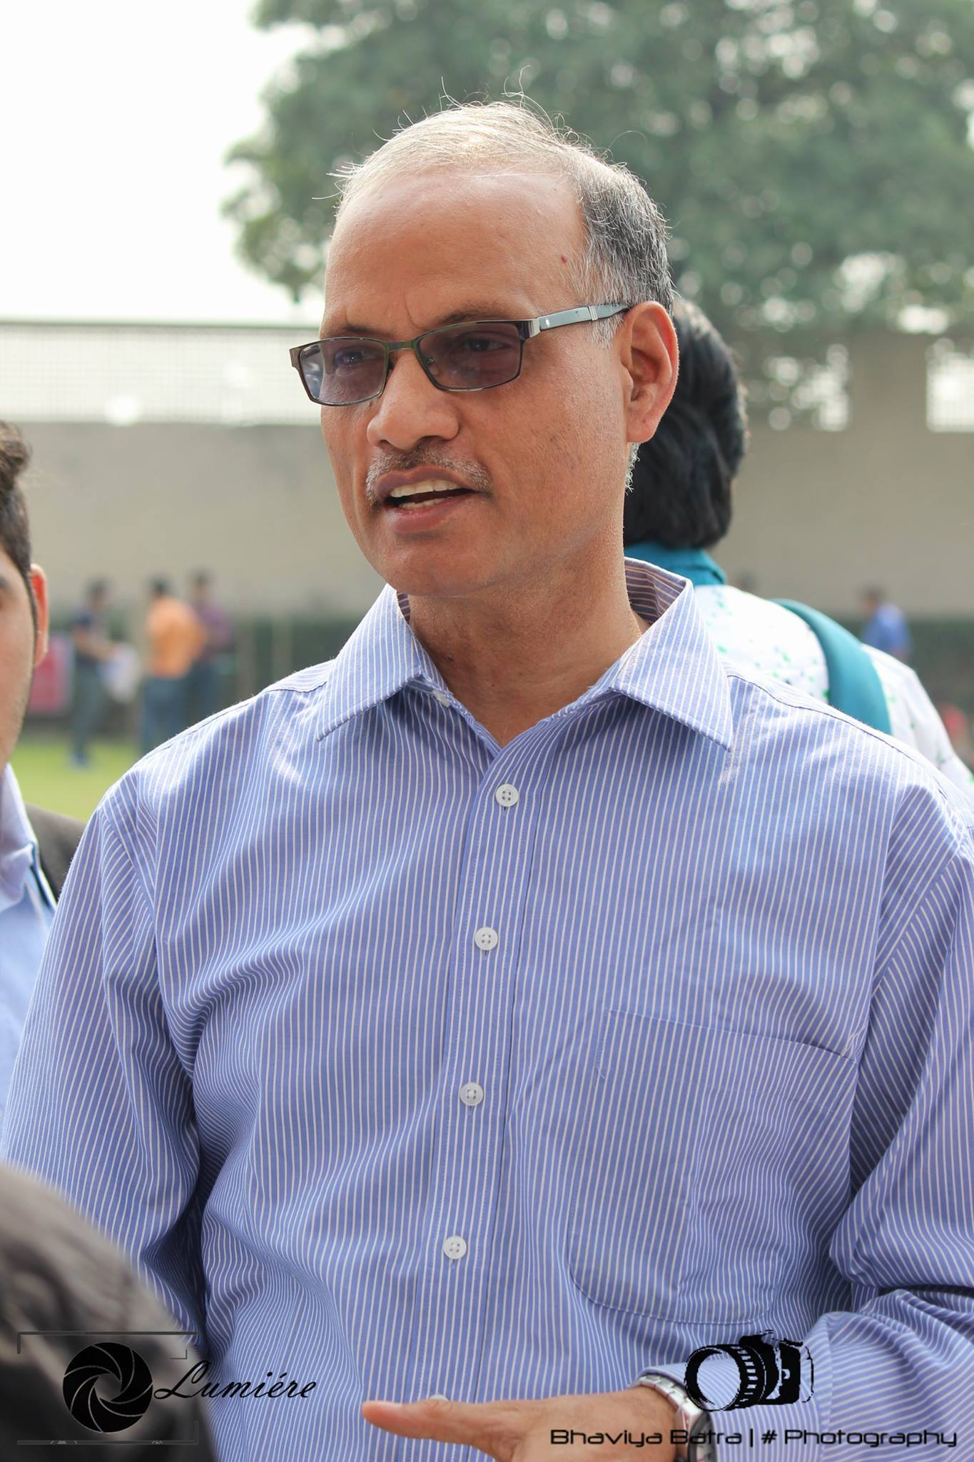

# Bechara Mara Gya : Abhimanch Play

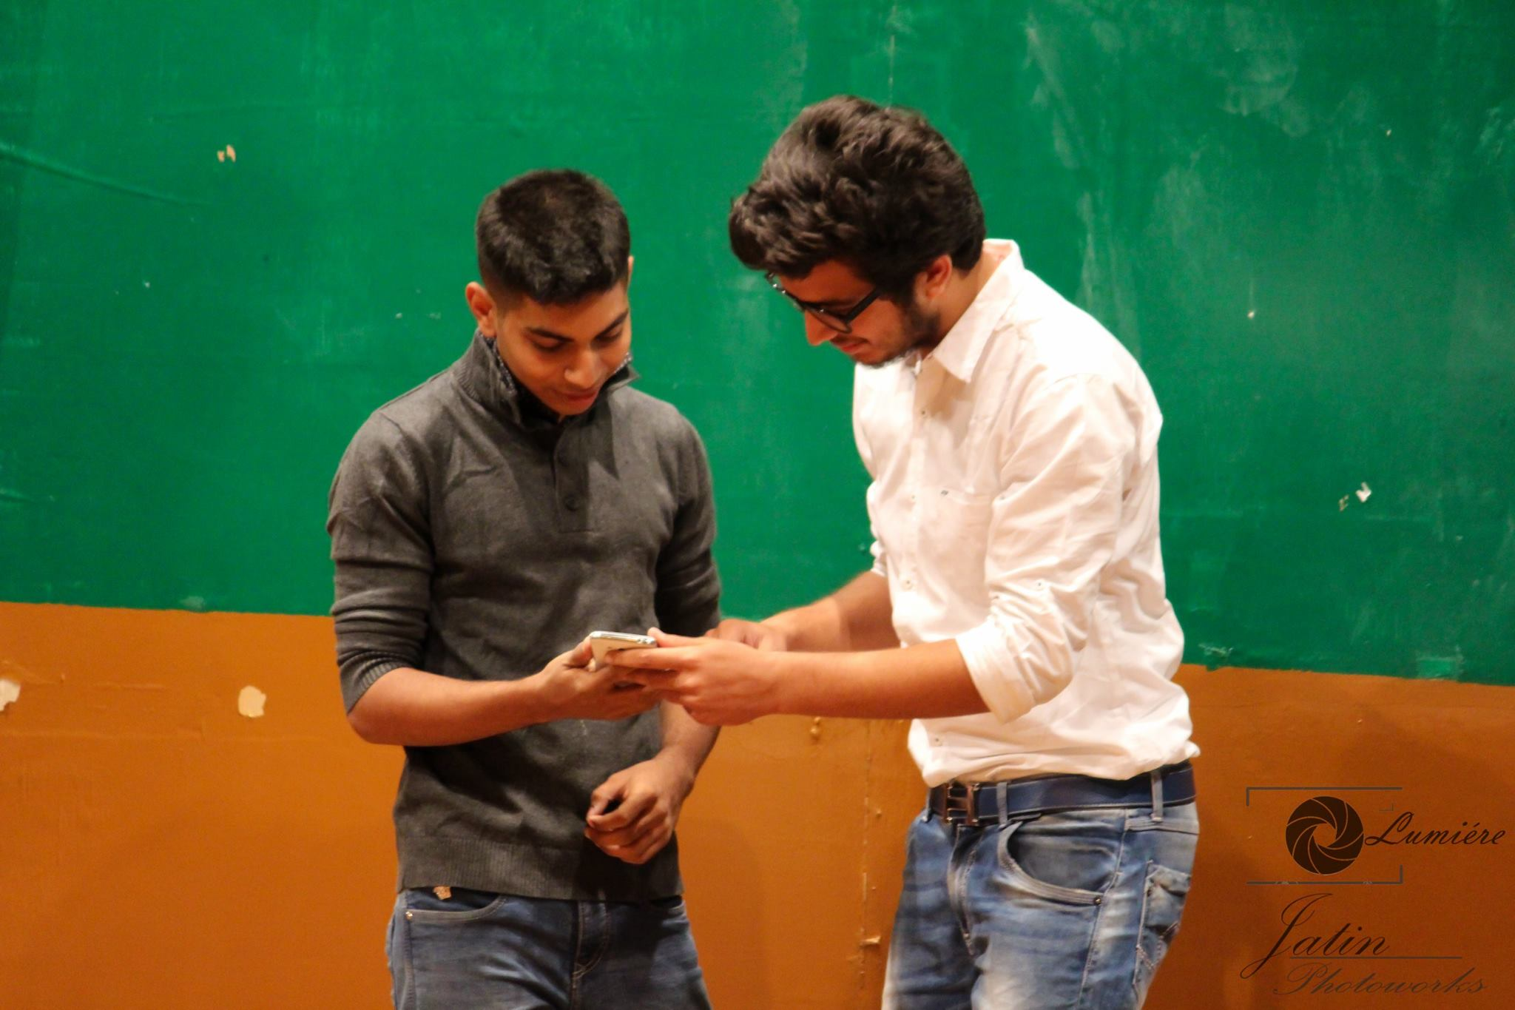

# Photowalk : NGO Aman Umeed Ghar

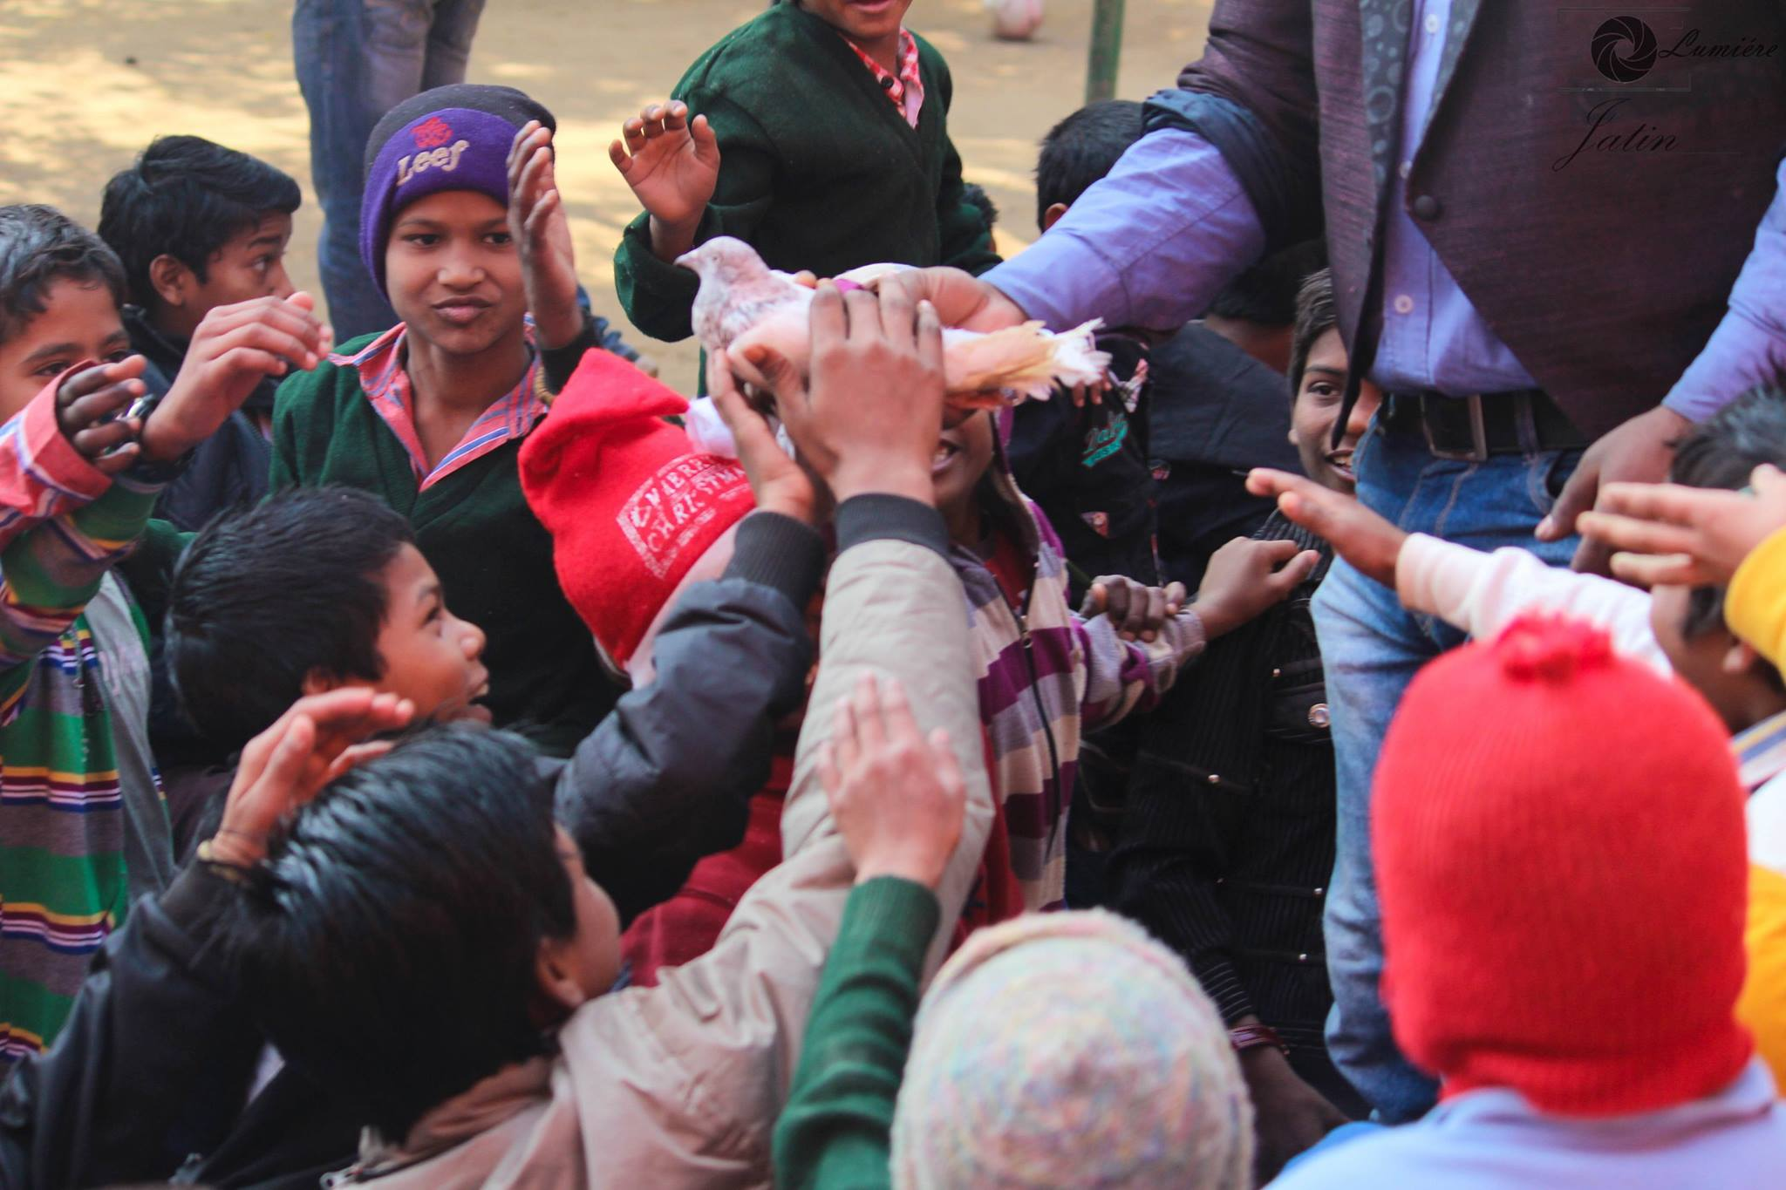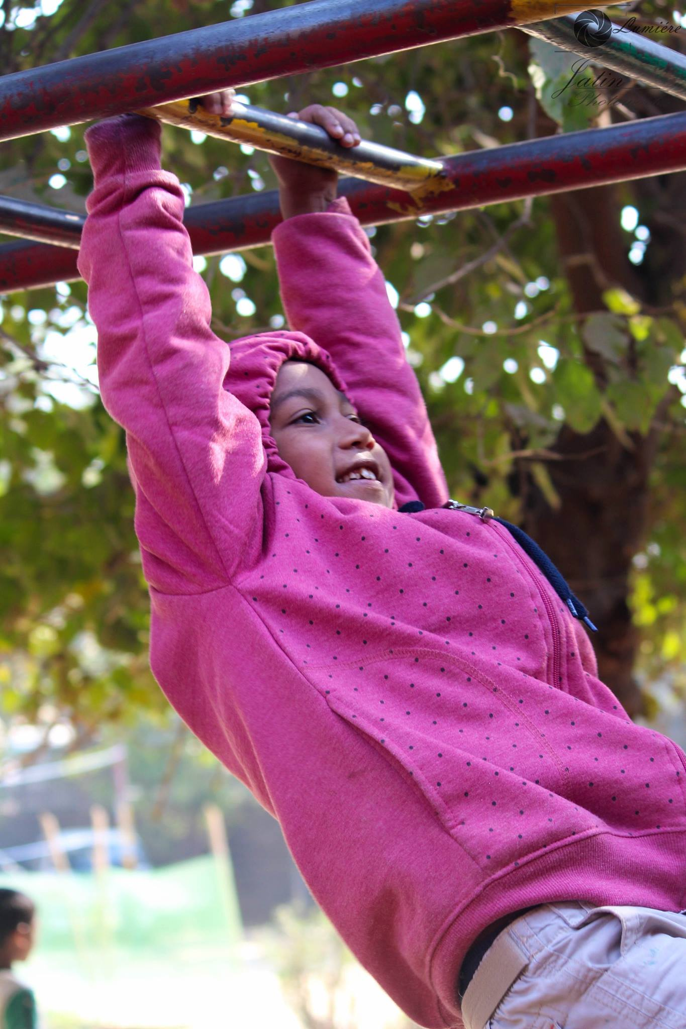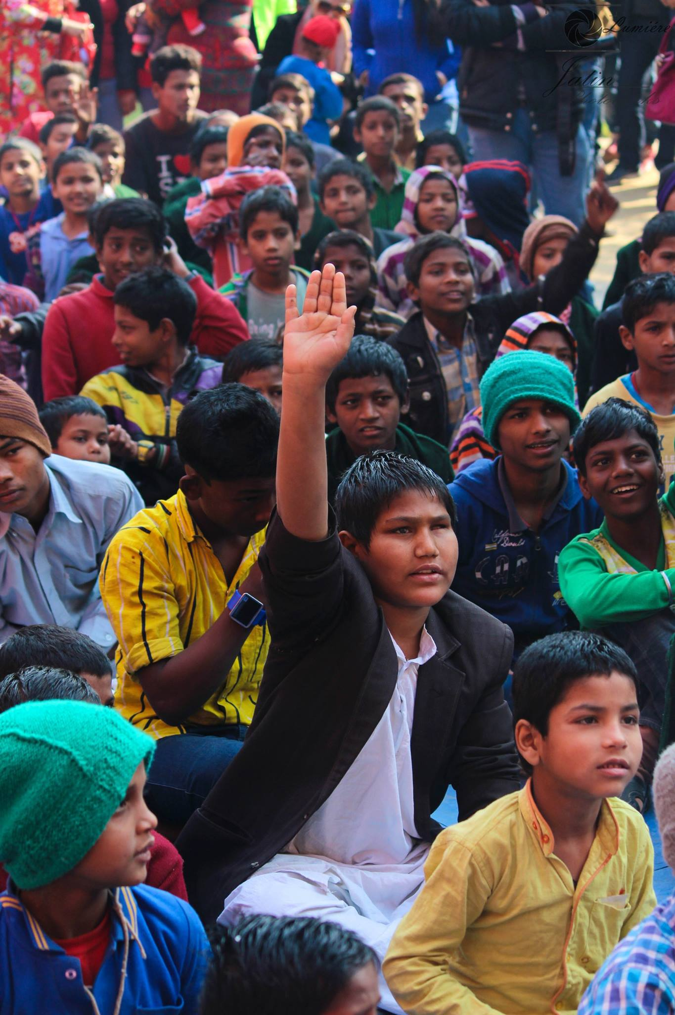

# Several Photography tutorials and classes

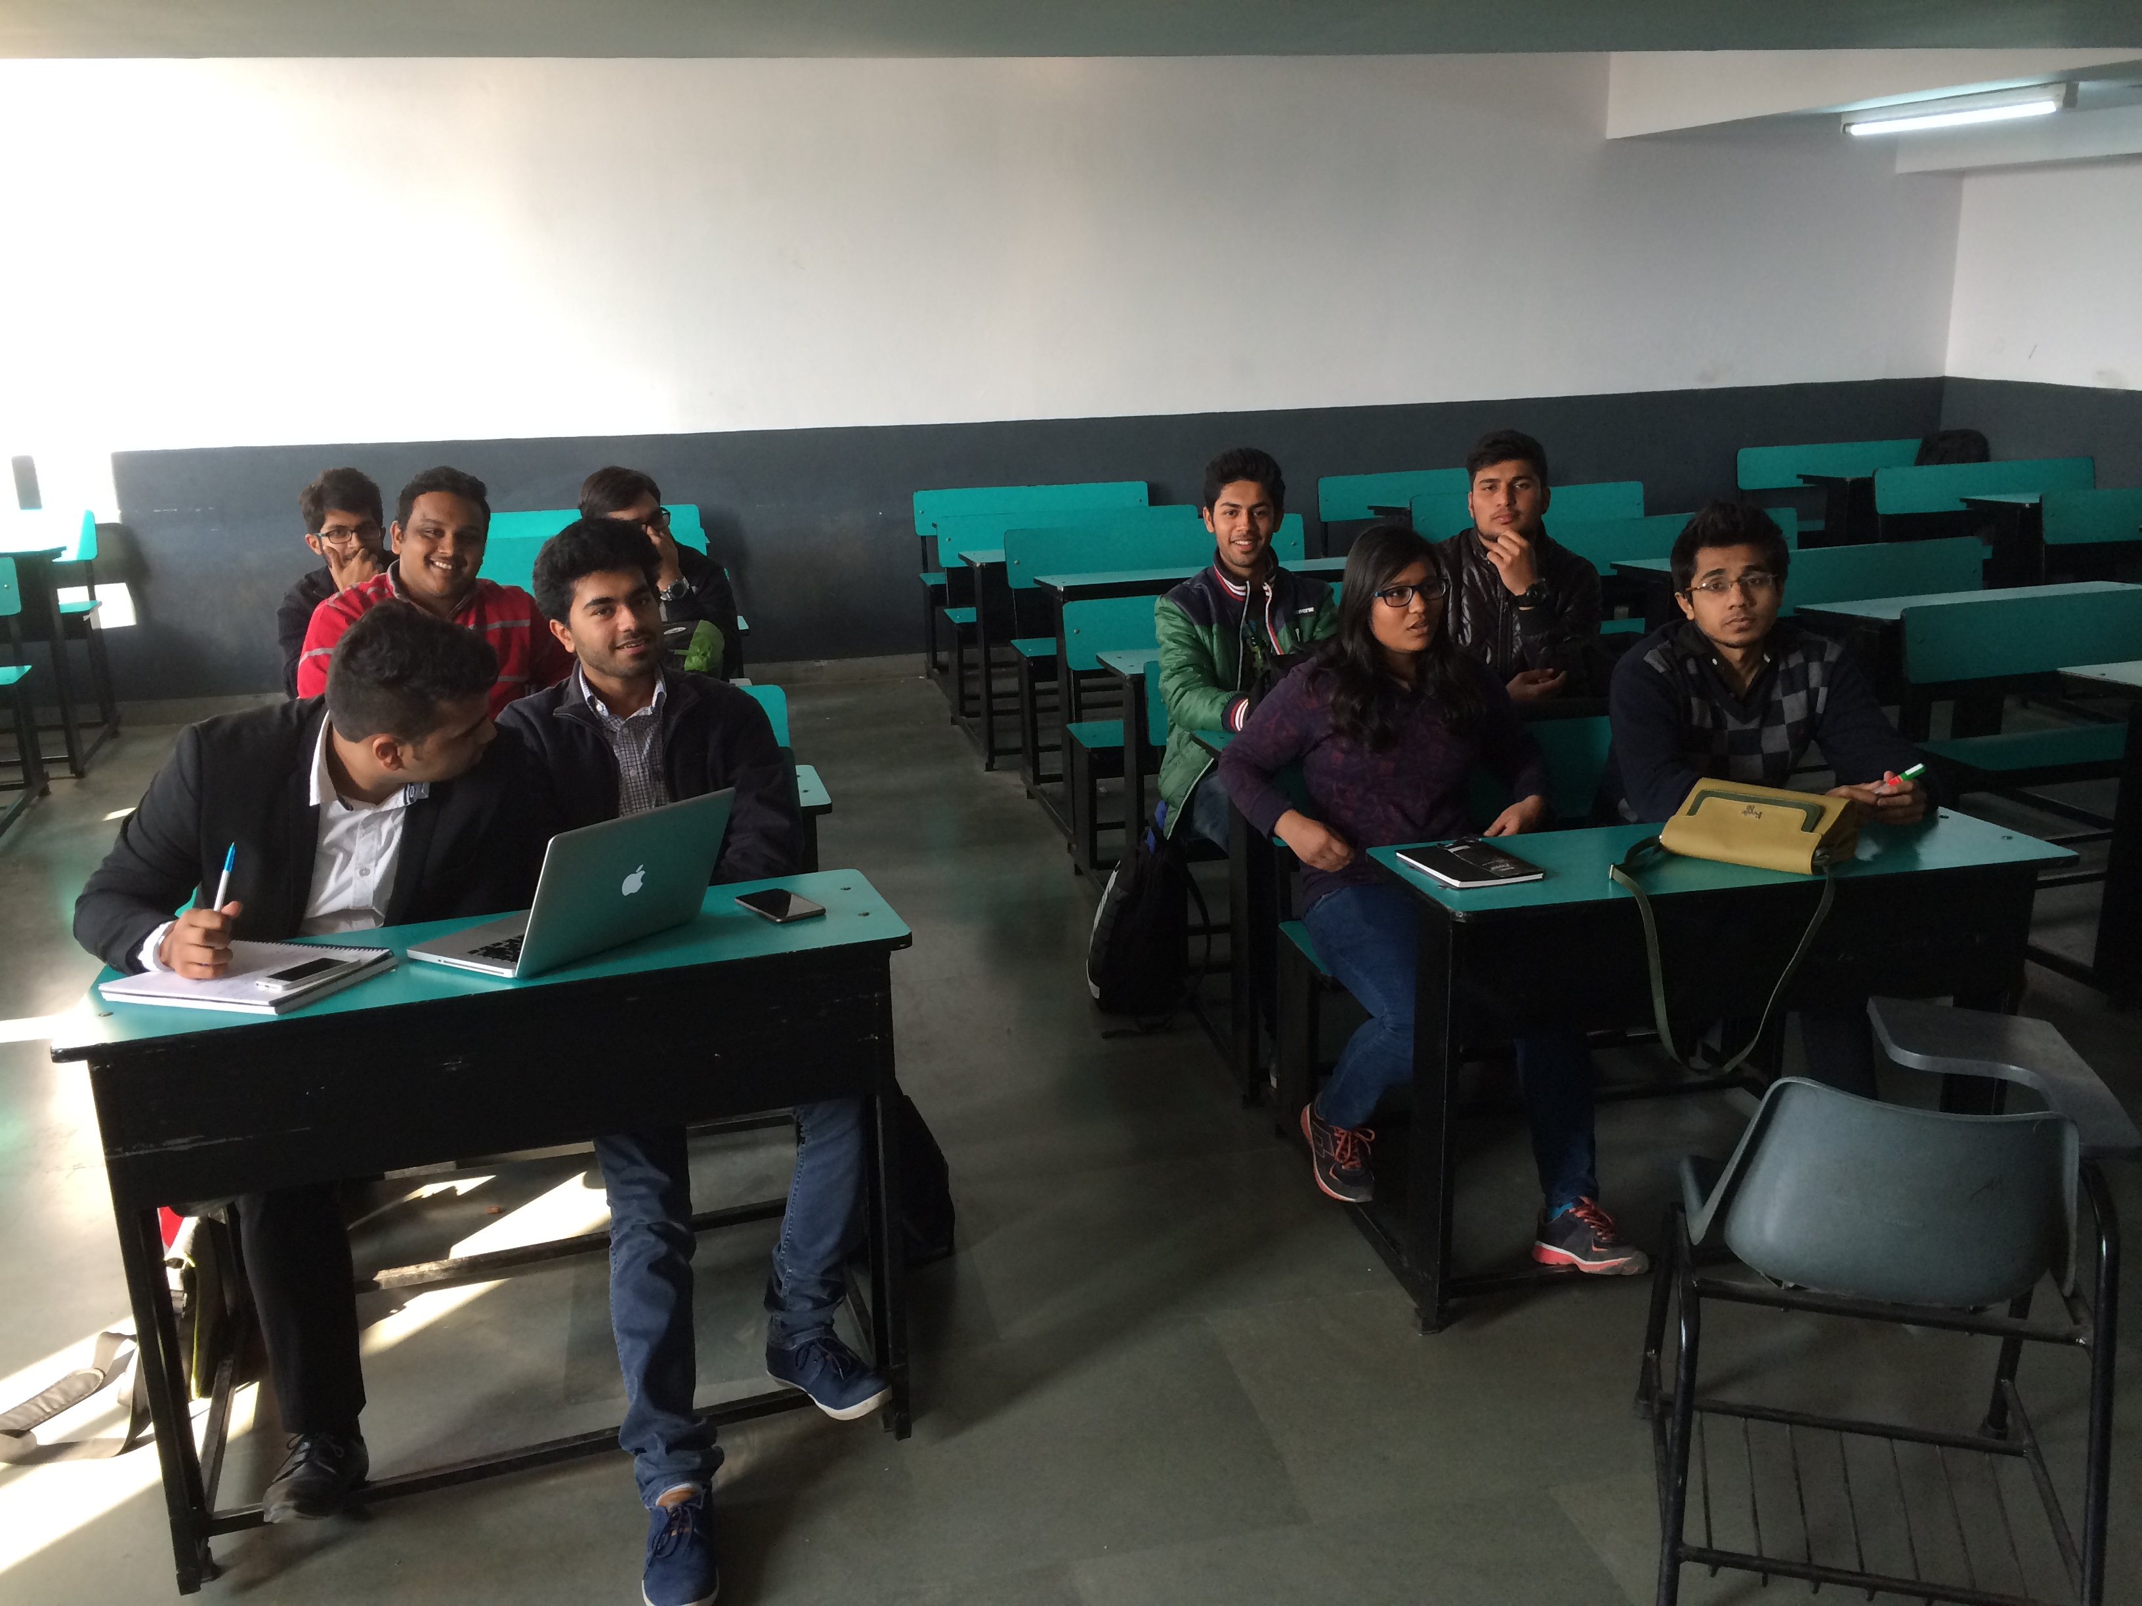

# Fiesta 2016

Photobooth with Lumiere photography exhibition

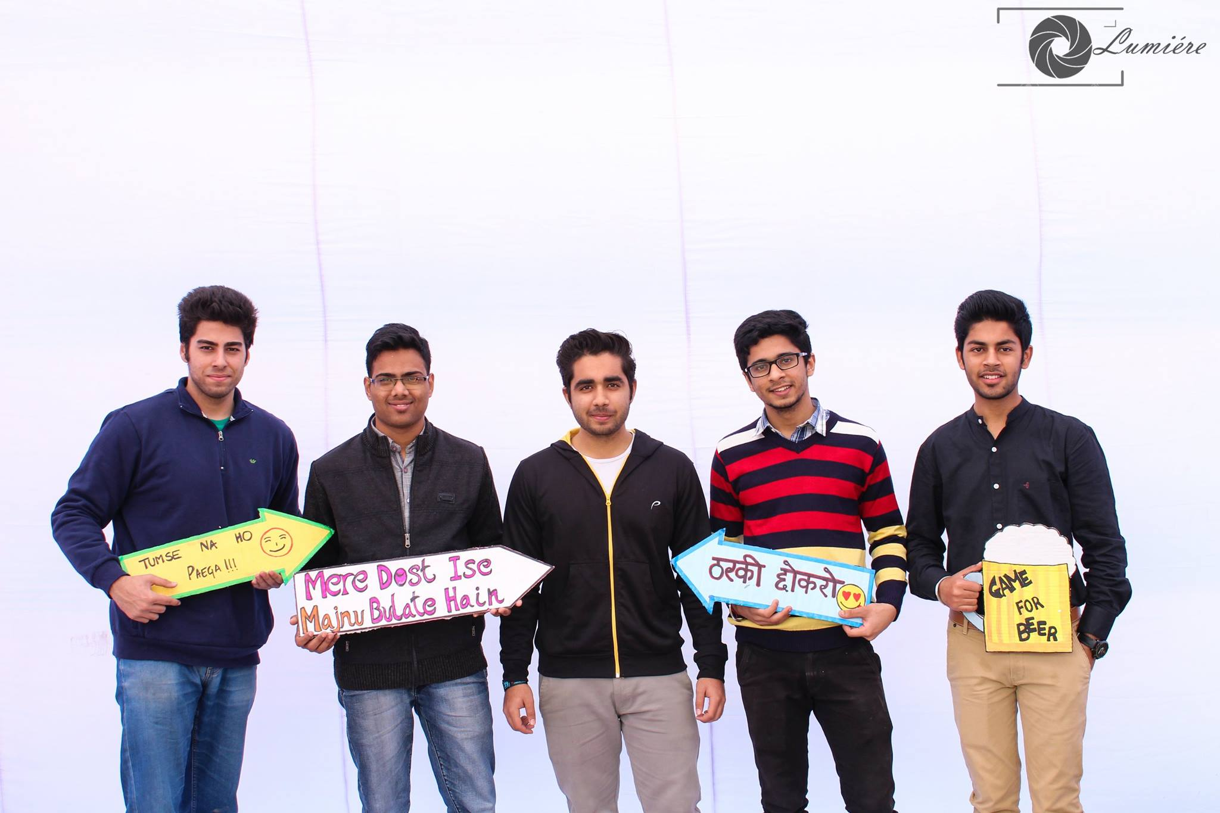

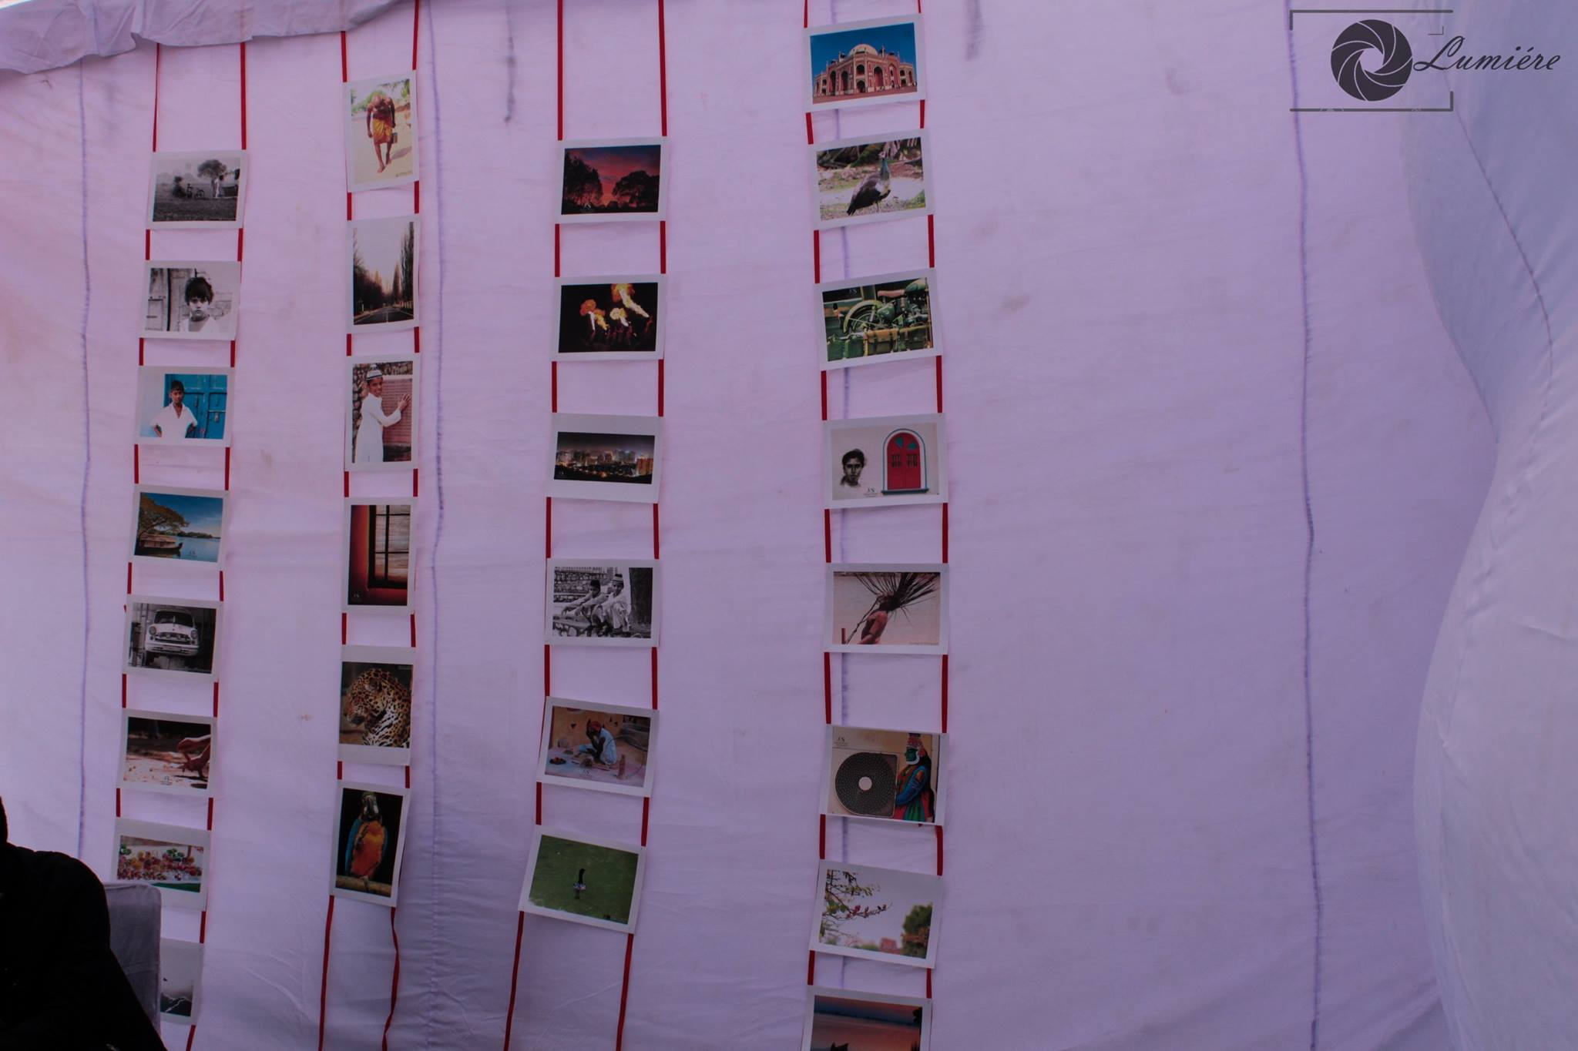

# Covered Fiesta 2016

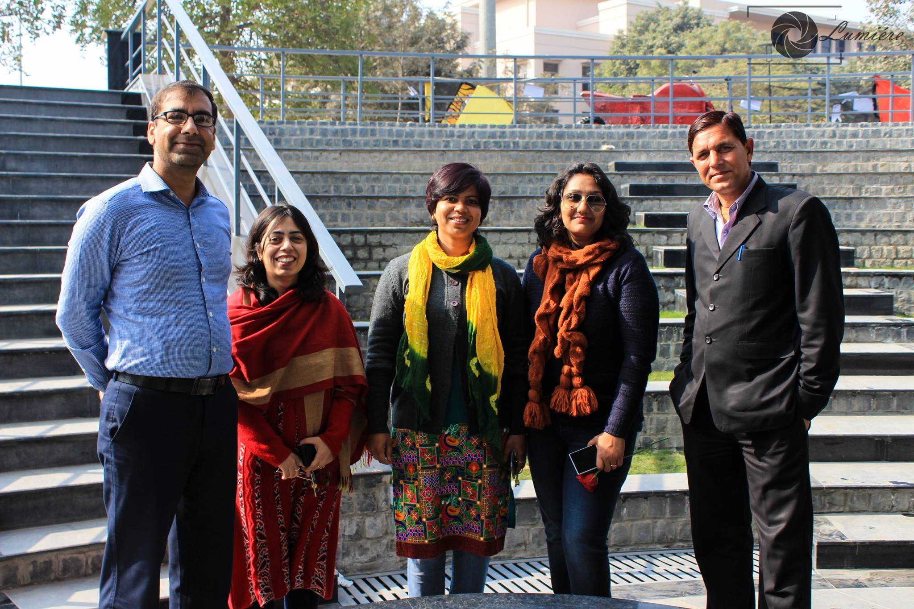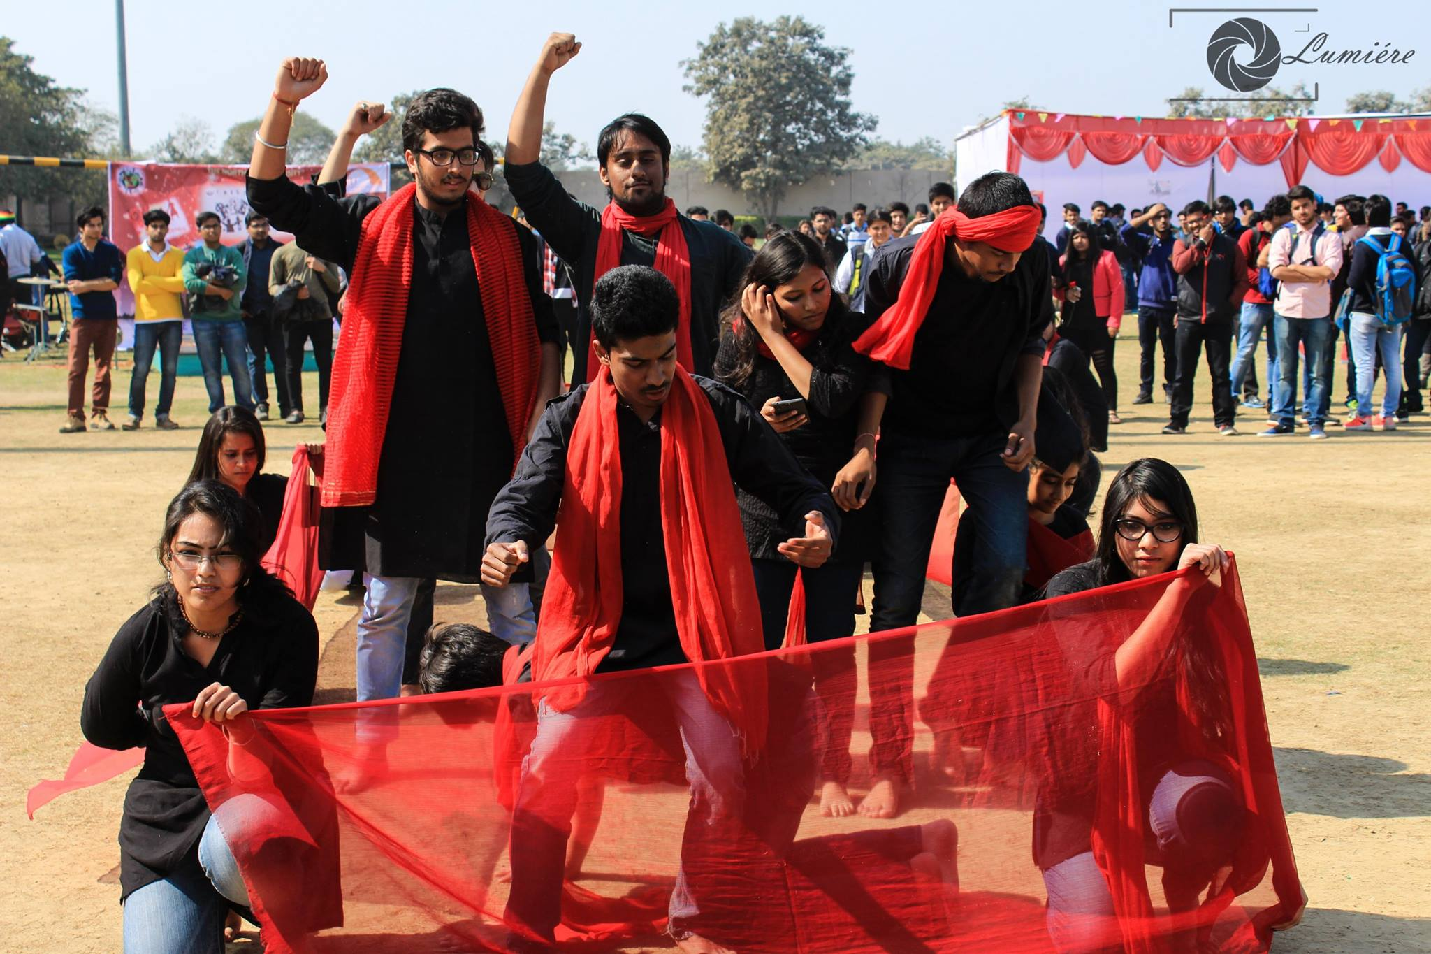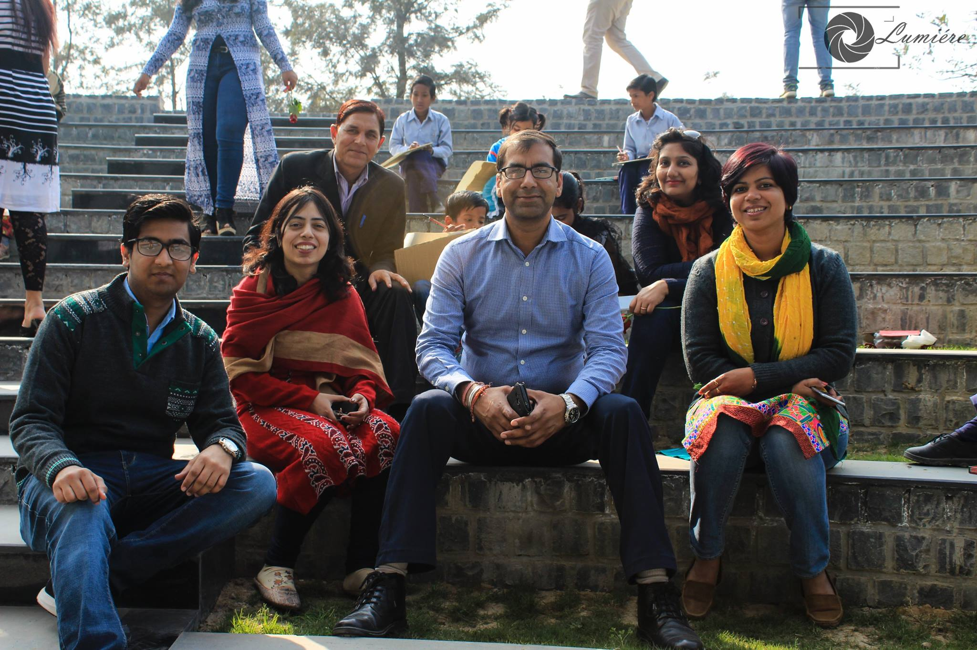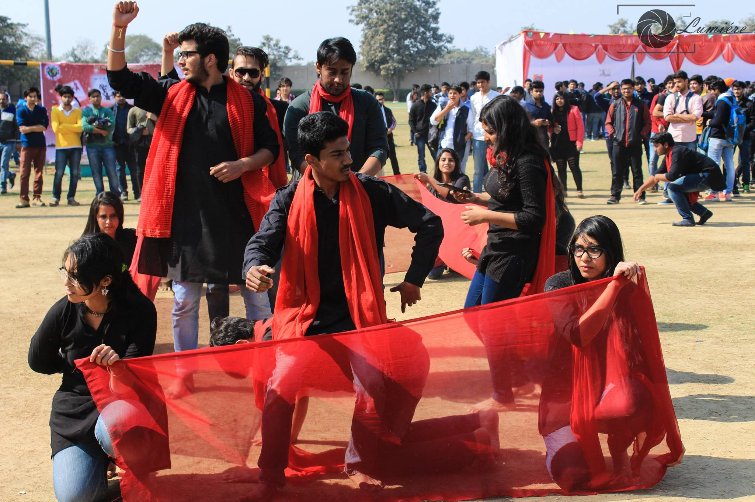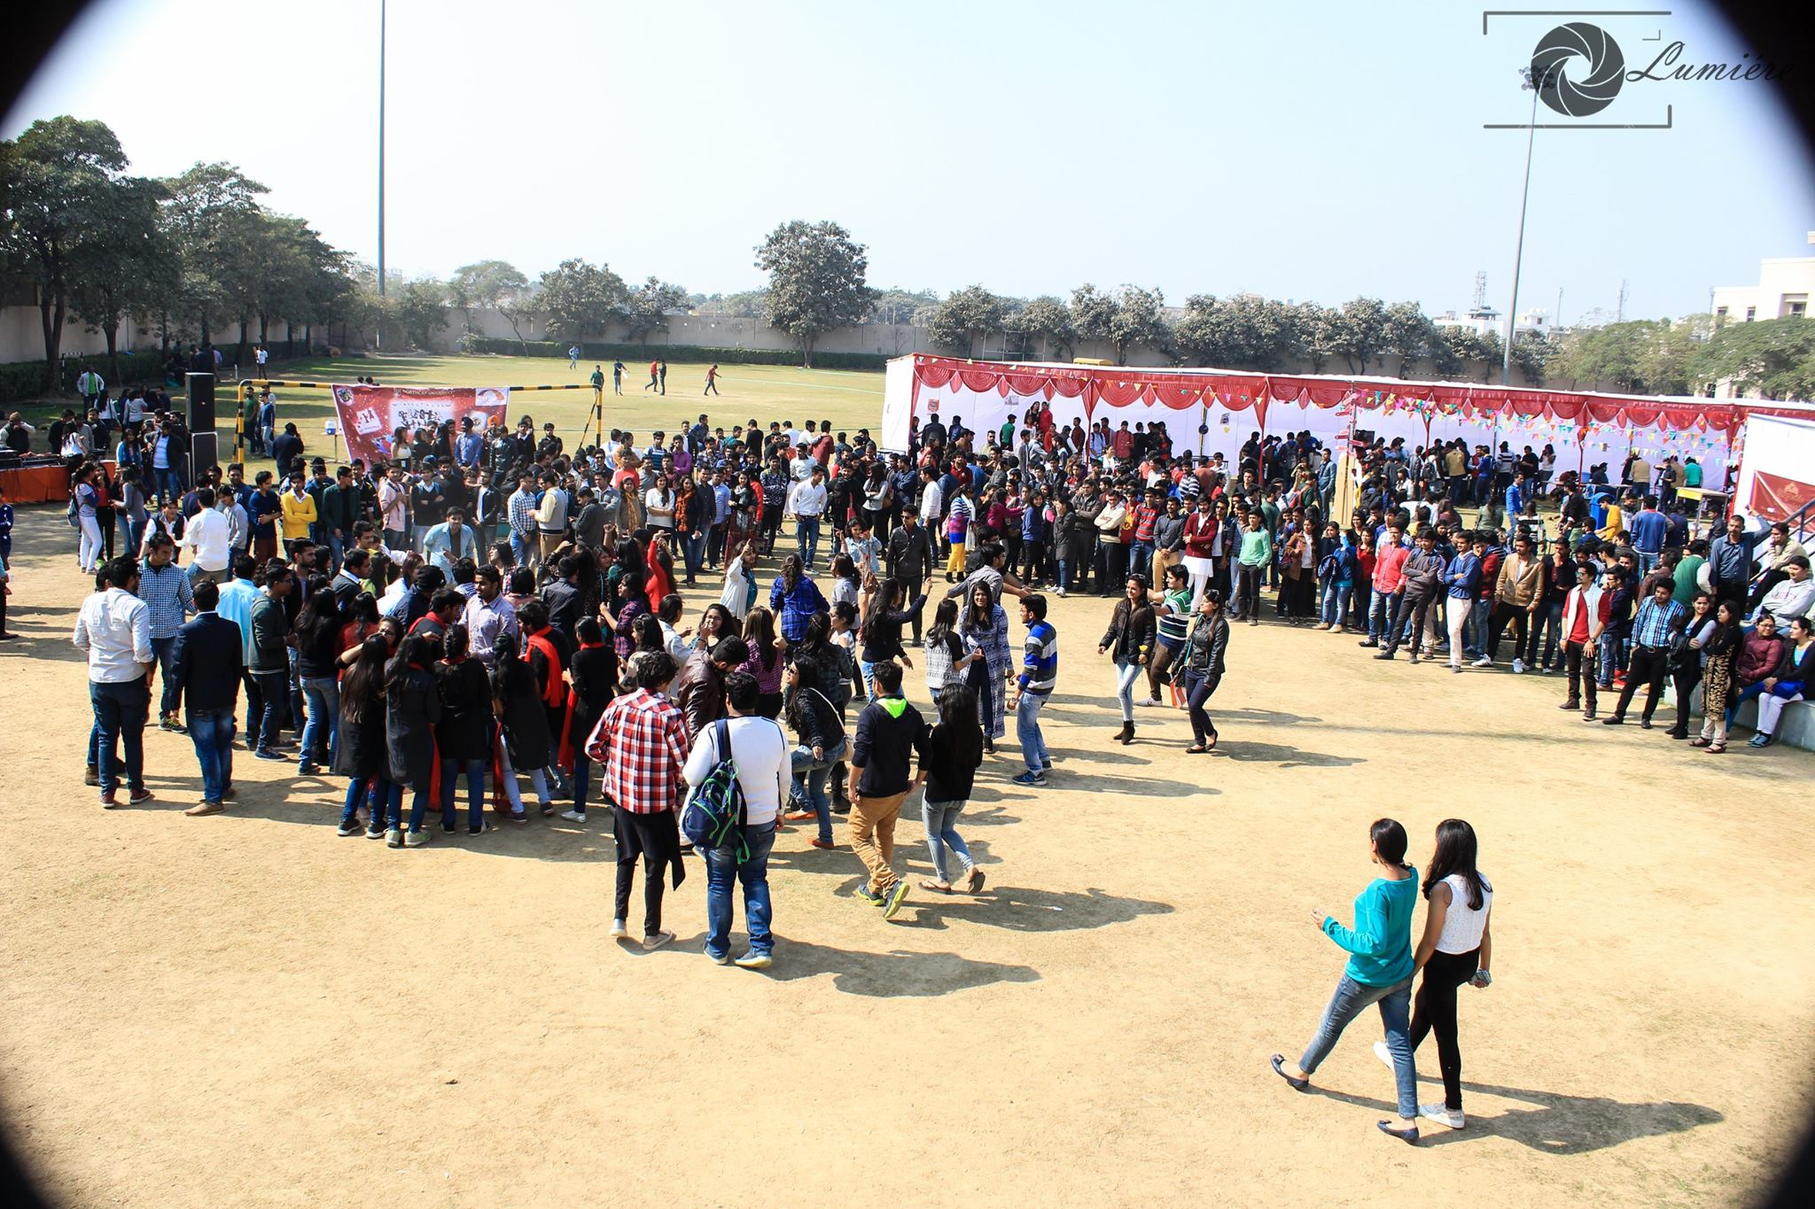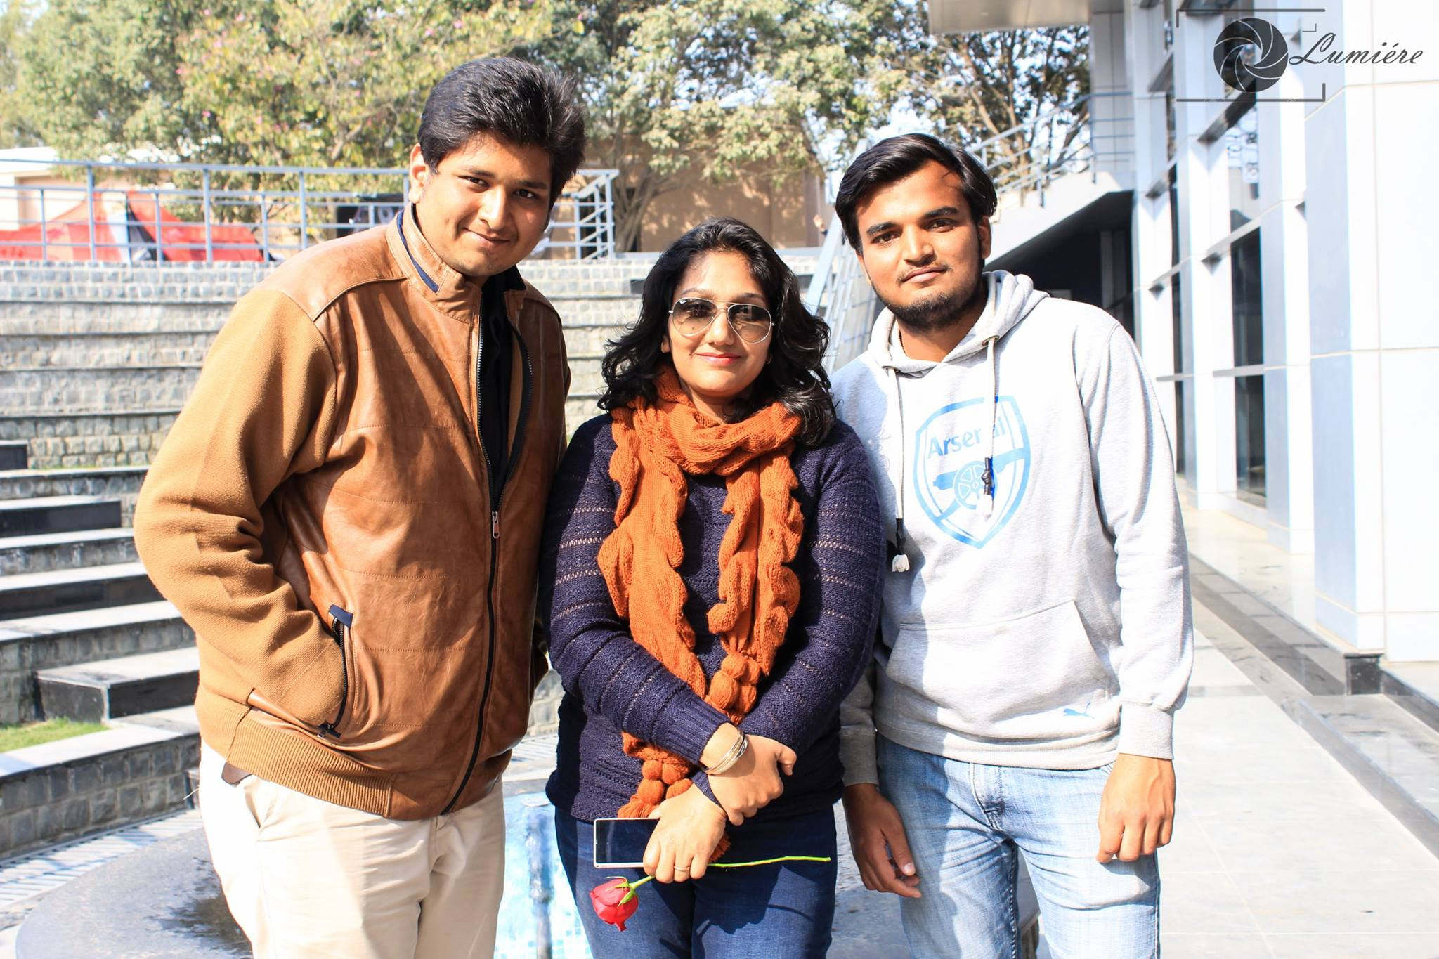

# Humans of NCU

A page on social media which helps in connecting alumni, students and staff of the university by sharing experiences and thoughts through the medium of a photography and a quote from the person. We have been uploading one photo on alternative day since August 2015 till now.

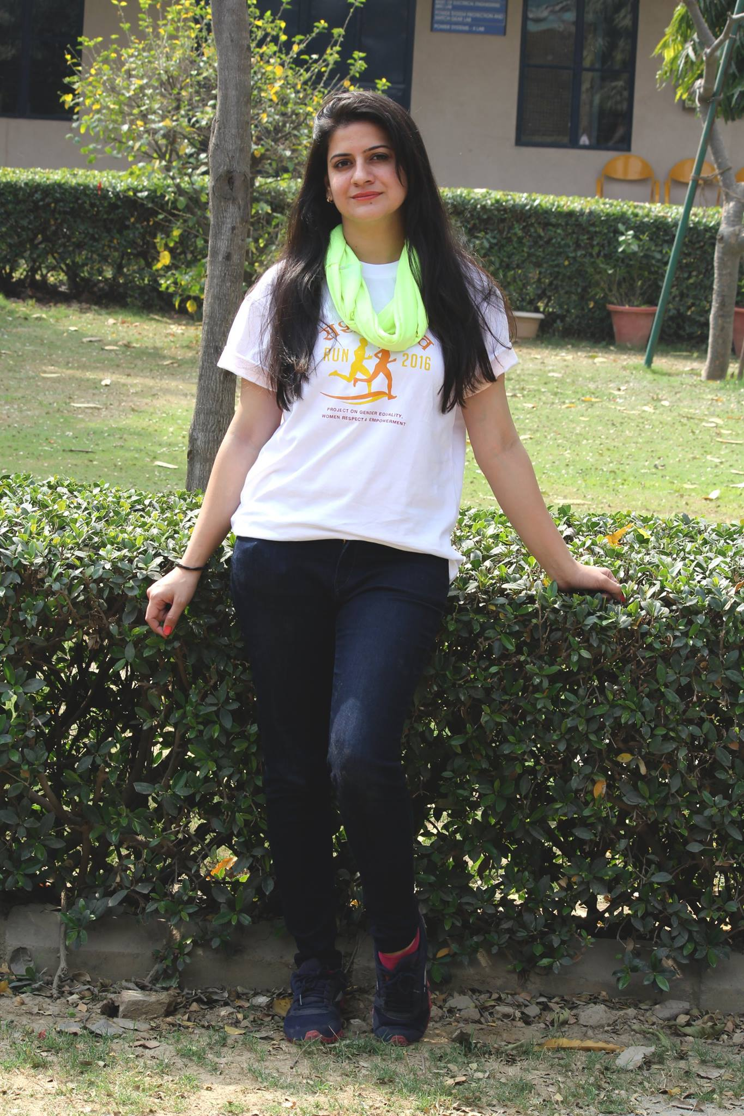

"We ran Mini Marathon to create awareness for women empowerment. It was a great experience and would love to do it again. A bit tired but felt energized due to the whole cause. Proud to be a part of this cause."

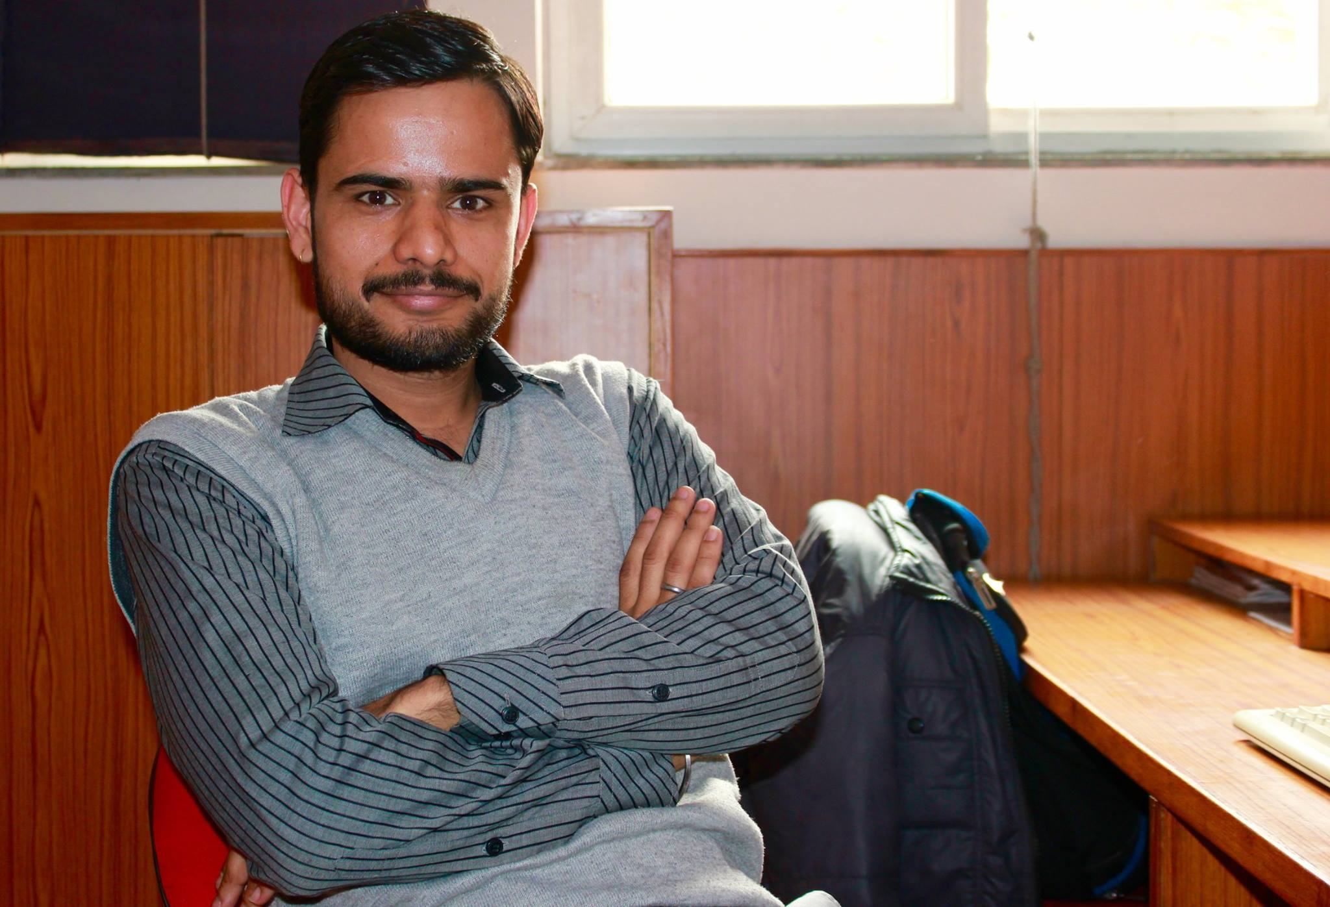

"What's your name, sir?"  
"Rohit Pant"  
"Do you like to travel?"  
"Yes. I love to travel. My last visit was to Ponta Sahib, Himachal Pradesh."  
"If given a week's paid trip anywhere in the world, where would you like to go?"  
"I'd love to go to Leh & Ladakh even if I'm given a free trip anywhere in the world. I love adventure. Being close to nature makes me happy.   
Also , I love adventure sports like Paragliding , Bungee jumping from a bridge. I have already done the former. I look forward to more experiences life will bring."

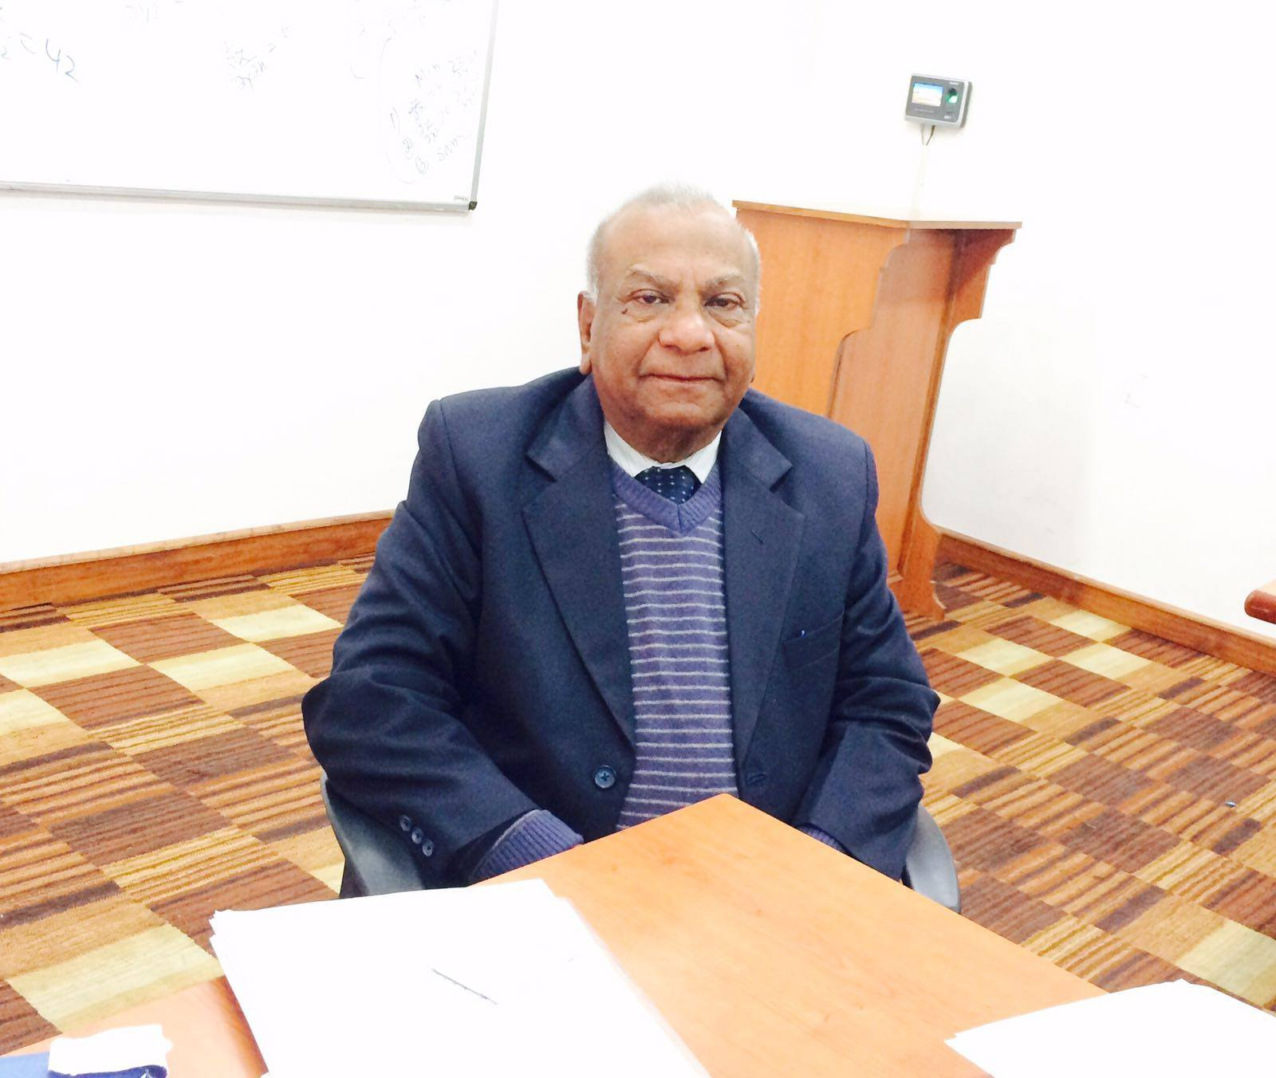

"Why teacher?"  
"I didn’t want to be a teacher. I become a teacher by chance not by choice. After completing my BSC I got admission in a very prestigious engineering college but due to bad financial condition of my family I pursued for M.Sc (maths) in 1961 and got the job so I joined. It’s all about destiny."  
"As you are going to take retirement soon from this college, tell me one incident that you will always remember in your teaching carrier?"  
"I’m going to complete my 55 years of teaching carrier in June 2016 without any break. I’ll never forget the affection and regards from students not only one batch or single student but from everyone ,everywhere I was posted."  
"Is there any advice you would like to give to your students?"  
"Yes! Don’t lose your heart, have a positive attitude, only hard work and do-get perseverance that will make you way apart. SO CALLED SUCCESS and your intelligence are not correlated to each other, but in my own experience truth prevails, your value prevails and adds a rosy picture to your goal."  
"Is hi baat par ek ganna yaad aata h- Ek raat jitni bhi sangeen hogi, Subah utni hi haseen hogi.  
Gham na kar ae baadal tu ghanere , Gham na kar ae baadal tu ghanere  
Aakhir kiske roke ruka h savera…"

# Lumiere 2016-2017

We are developing a website like Google Students Club, to showcase and get more reach, and try to continue to keep these activities on with much more new activities to follow.  
Thank You